**Index**

|  |  |
| --- | --- |
| 1 | 1.1 Integer and Character type variable  1.2 Taking int value at once and adding  1.3 Taking character value (single char)  1.4 Float and double: |
| 2 | 2.1 Conditional Logic  2.2 Modulus means bhaagshesh %2, 2 diye bhaag hole bhagshehsh  2.3 Checking vowel or not : if else condition  2.4 Checking digit or not  2.5 Use of else if in grading system |
| 3 | 3.1 Loop introduction  3.2 While loop  3.3 for loop: even number with if condition  3.4 break and continue  3.5 For nested loop  3.6 Sum Dhara  3.7 Loop Star pattern |
| 4 | 4.1 What is Function?  4.2 prototype of function for this example  4.3 Normal problem solving without creating function  4.4 Some examples of Function  4.5 Array  4.6 one dimentional array  4.7 2D array  4.8 2D array more detailed examples |
| 5 | 5.1 String intro  5.2 String Initialization  5.3 String length counting  5.4 Reversing string  5.5 String connection  5.6 ASCII  5.7:String Array means Character array er array |
| 6 | 6.1 File input/output  6.1.2 Use of fscanf and fprintf: input_output both using file  6.2 Structure: Collection of variable  6.3 Structure Array  6.4 File Shortcut : without FILE pointer or fopen |

**C Prgramming syntax and concepts**

1.1 Integer and Character type variable:

**Taking int value one by one and adding :**

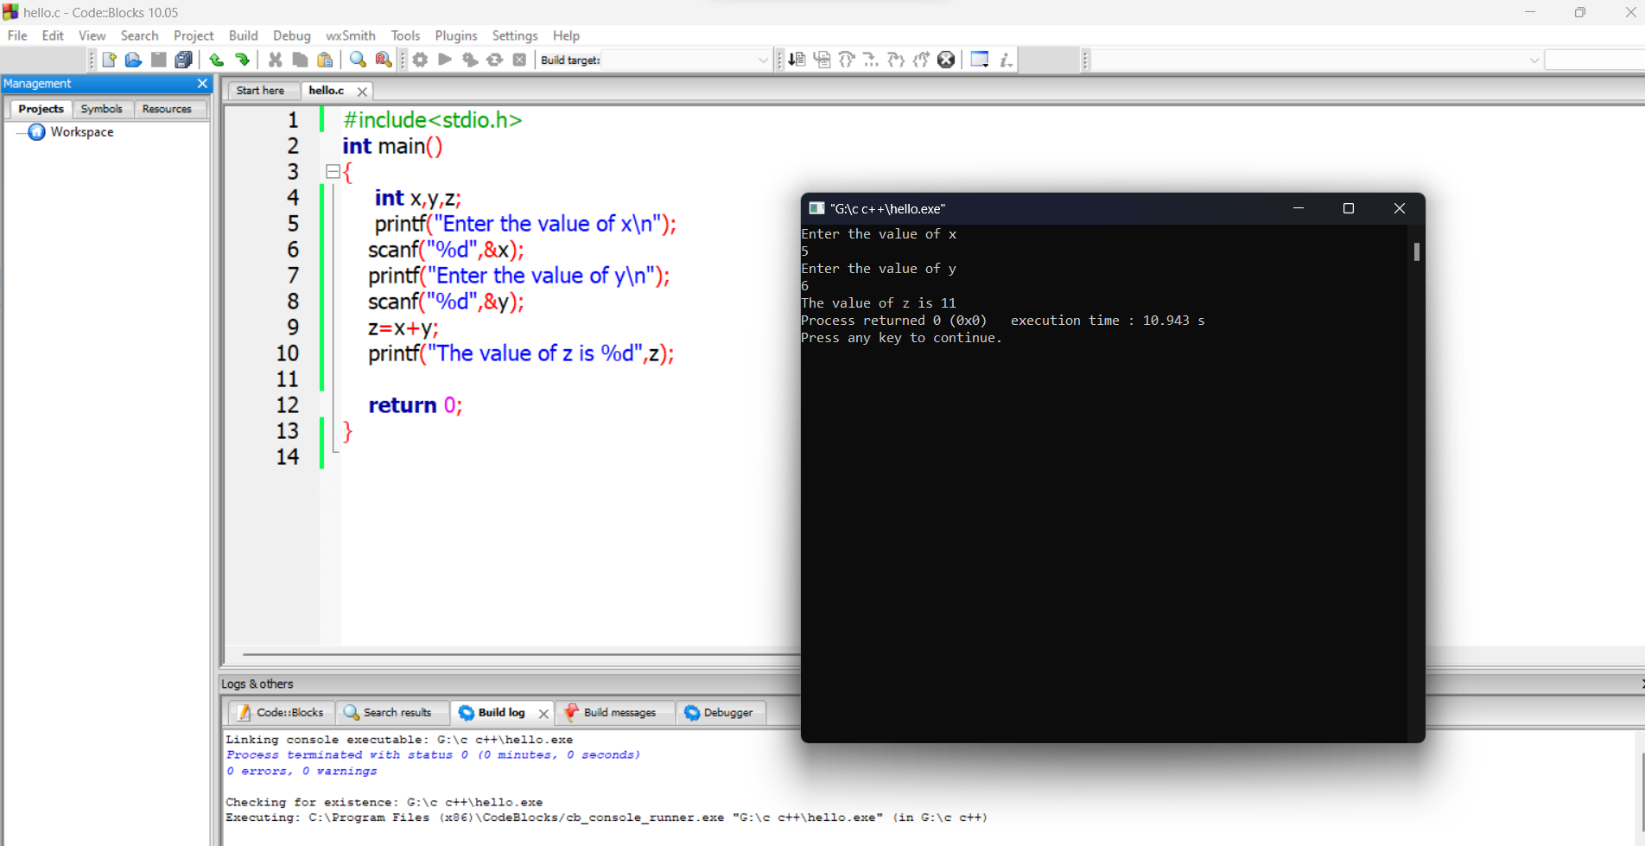

**1.2 Taking int value at once and adding :**

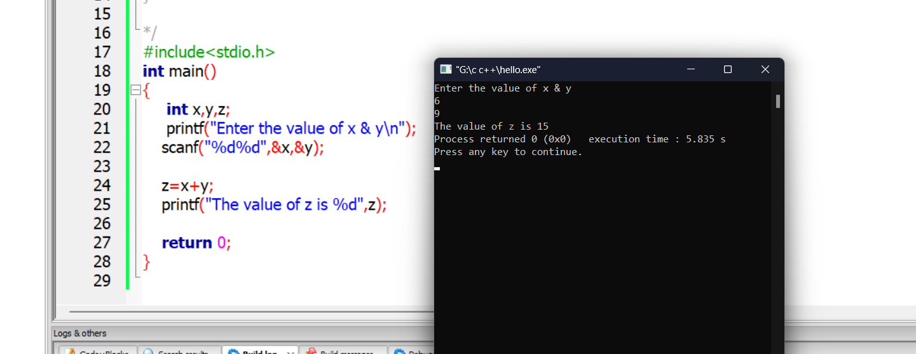

**1.3 Taking character value (single char):**

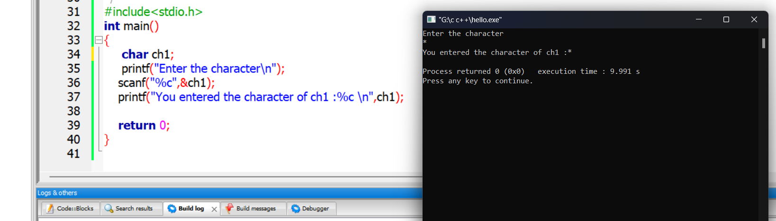

**1.4 Float and double:**

**float and double both have varying capacities when it comes to the number of decimal digits they can hold. float can hold up to 7 decimal digits accurately while double can hold up to 15.**

**.2 means after the int value 2 fractional number will be printed**

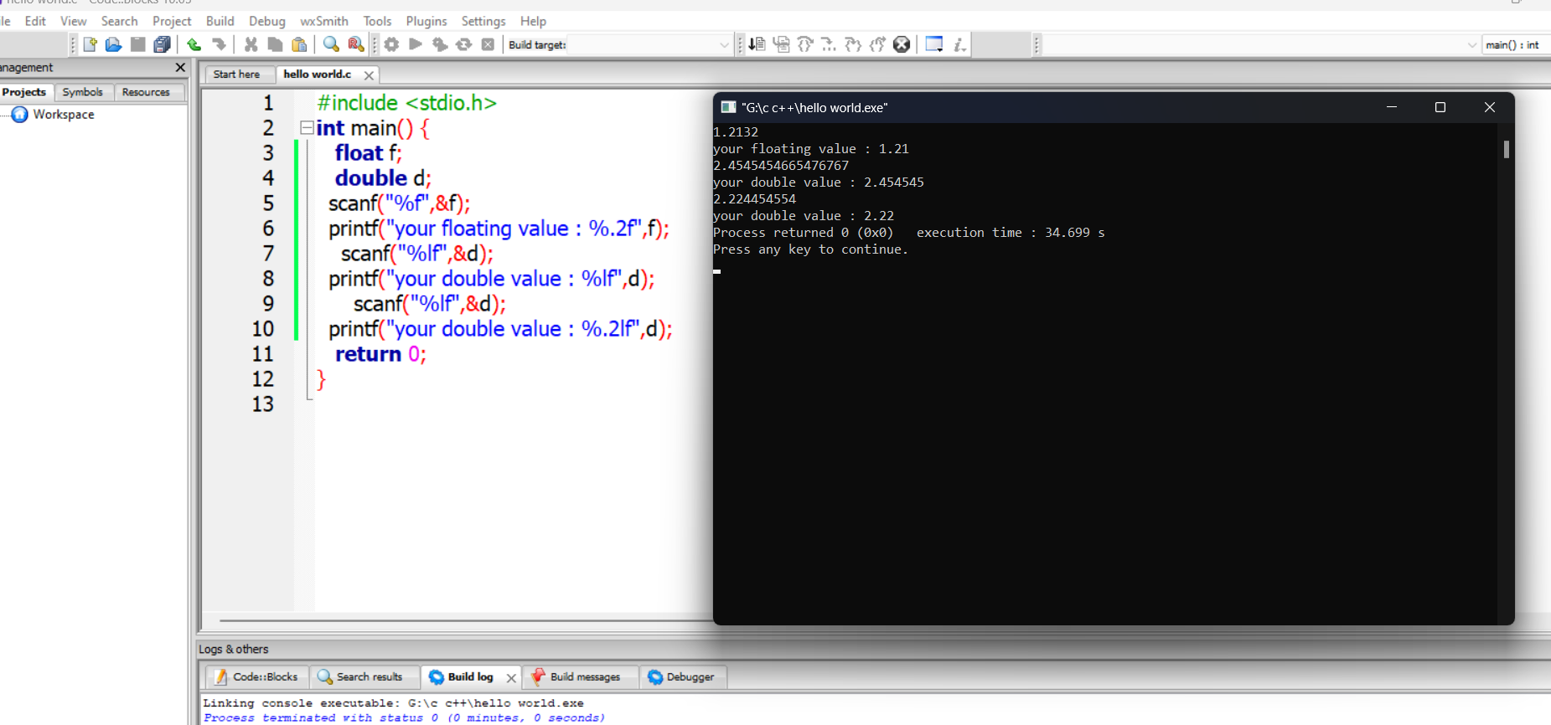

**2.1 Conditional Logic**

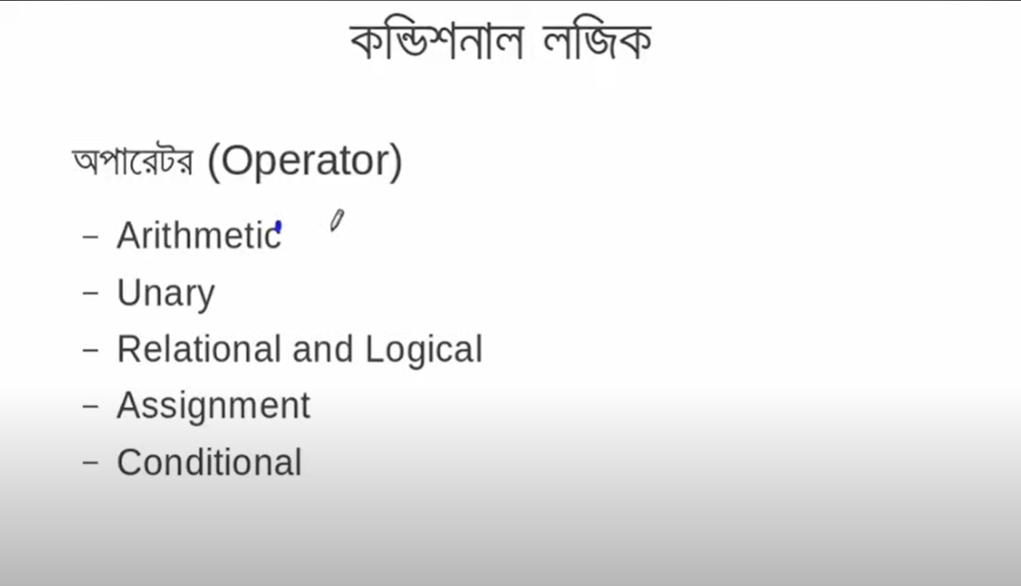

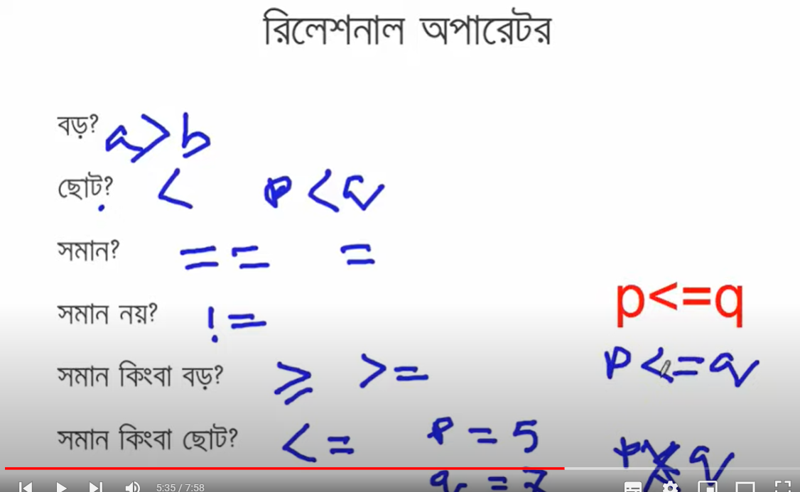

**Conditional logic:**

**If x condition is true**

**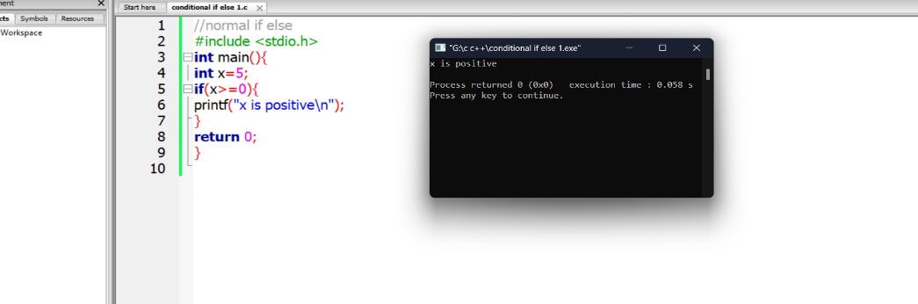  
won’t run if not following the condition without else:**

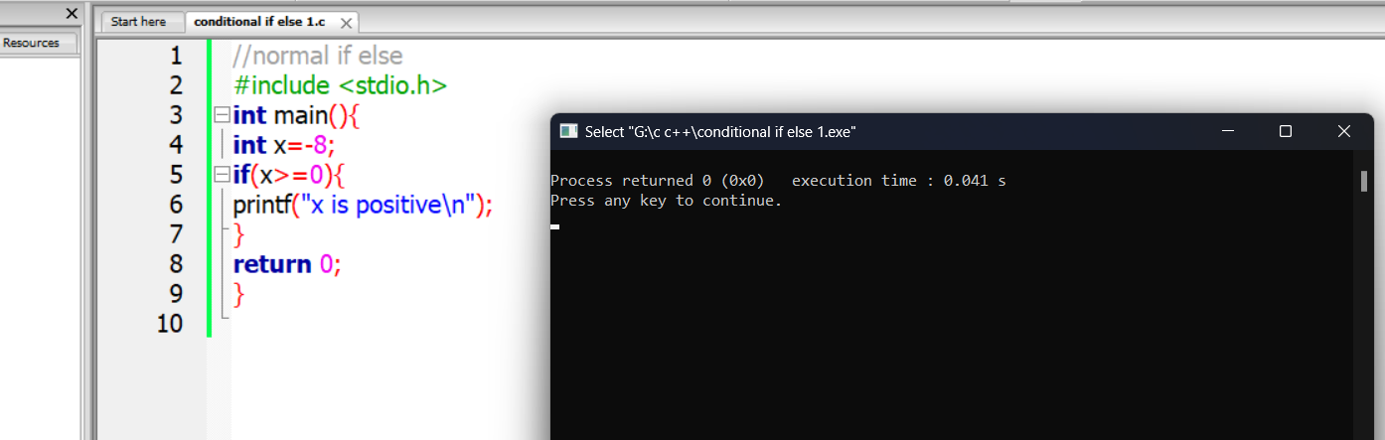

2.2 Modulus means bhaagshesh %2, 2 diye bhaag hole bhagshehsh

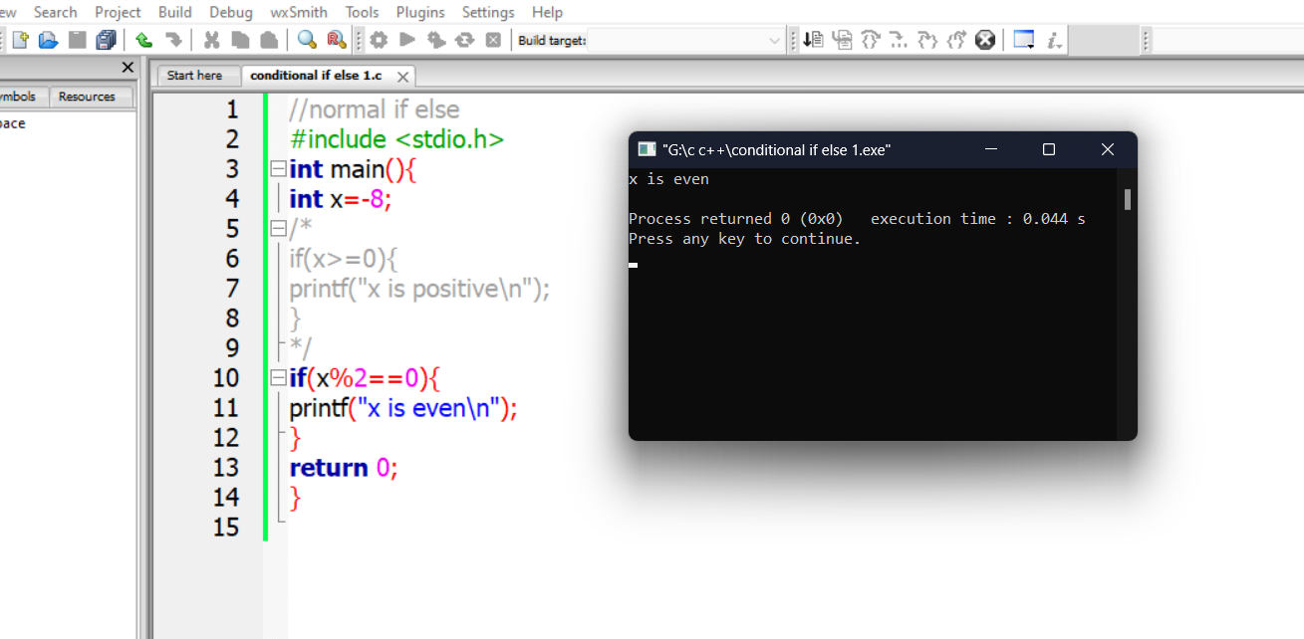

**Using more variable to make simple bracket form:**

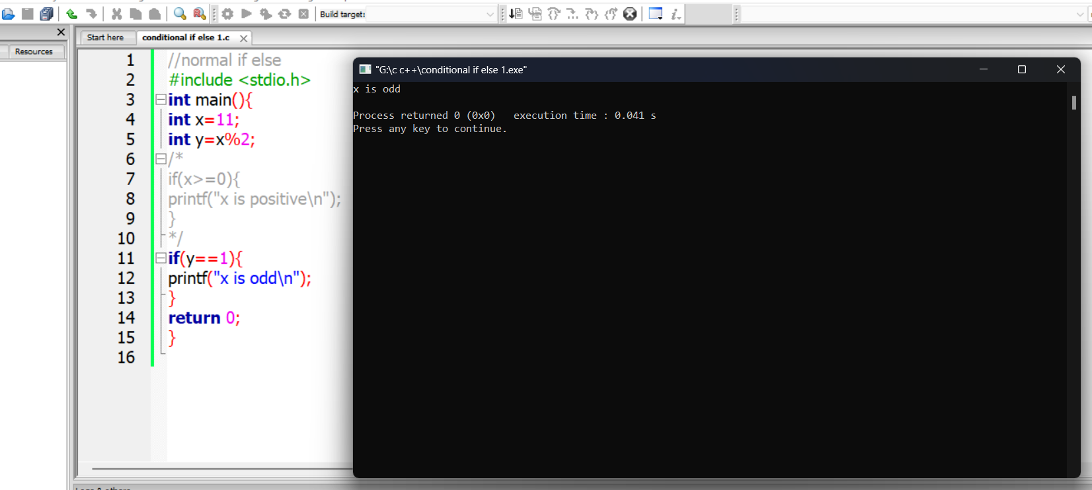

**Else Condition:**

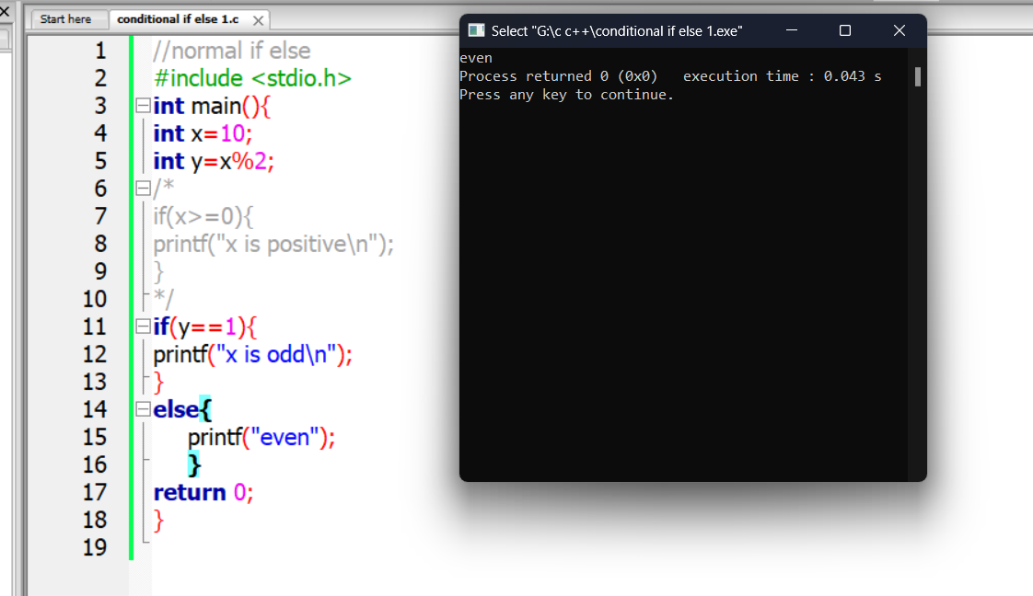

**2.3 Checking vowel or not : if else condition**

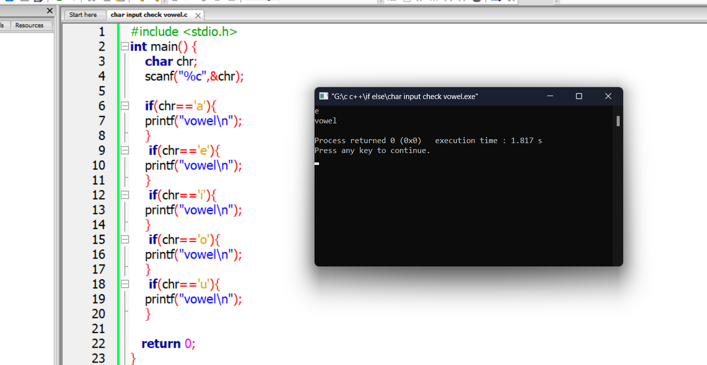

**Short form:**

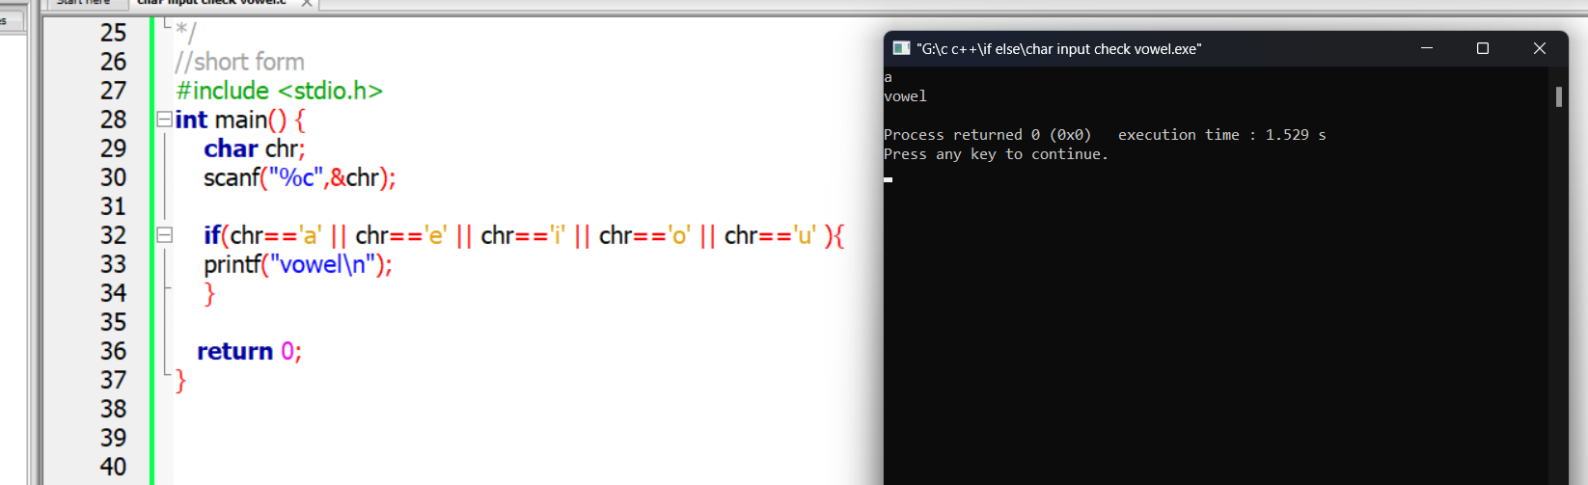

**Bug free:**

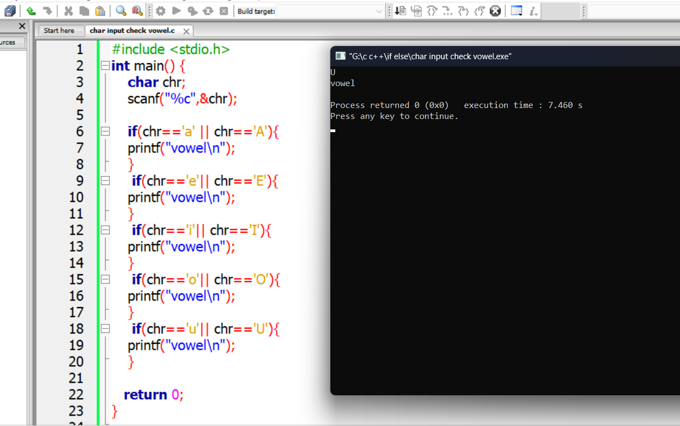

**Logical operator:**

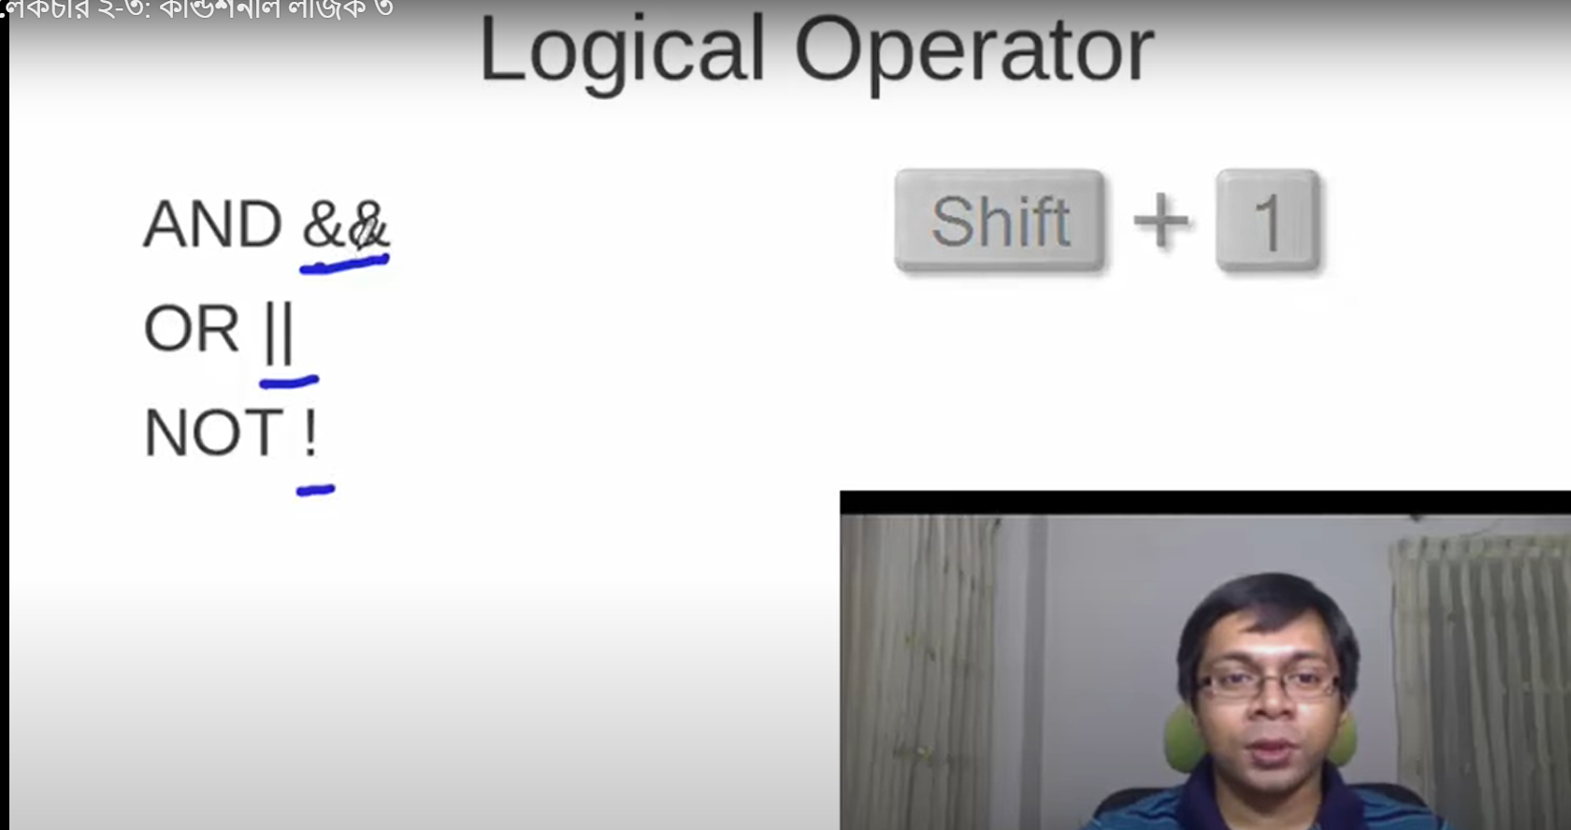

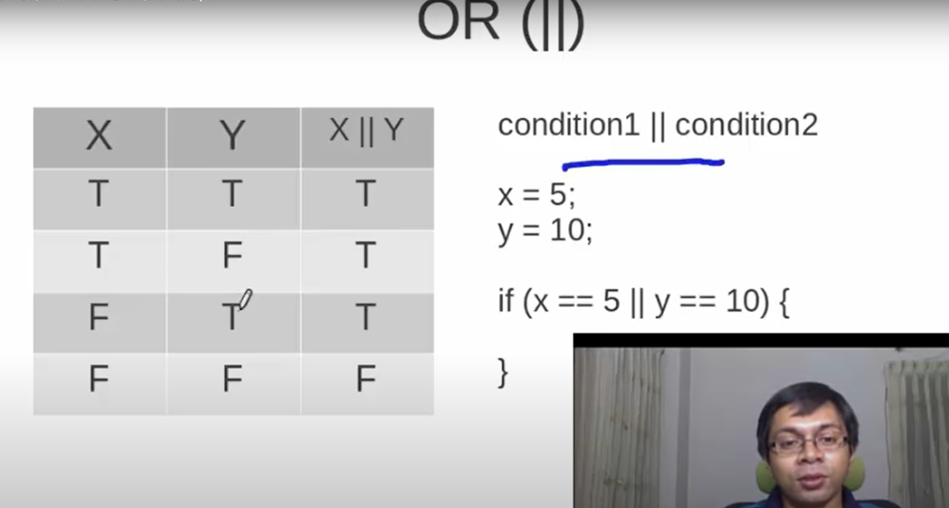 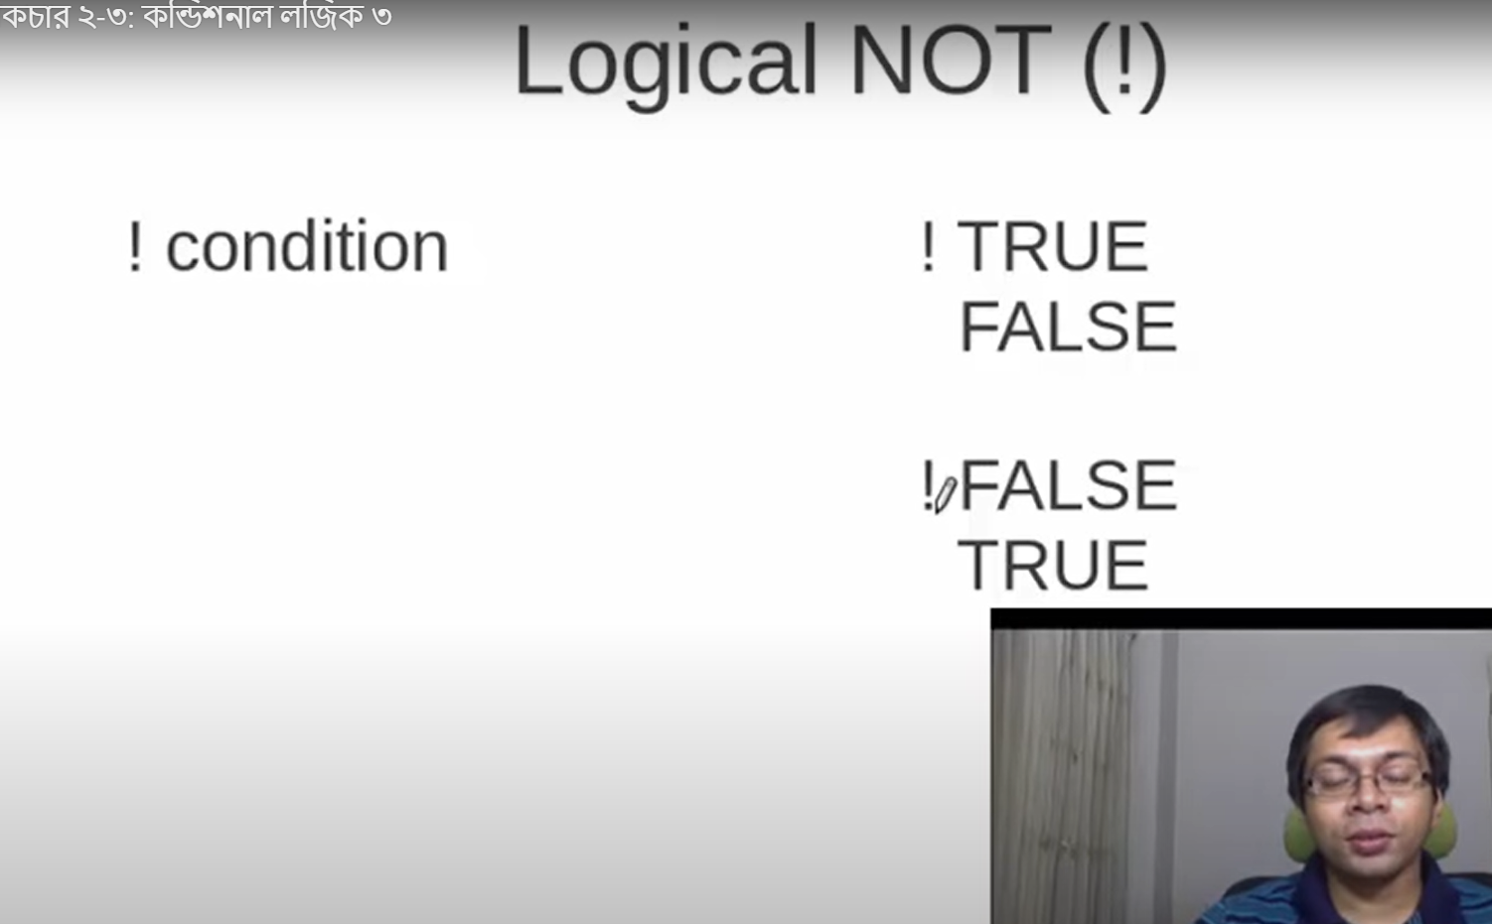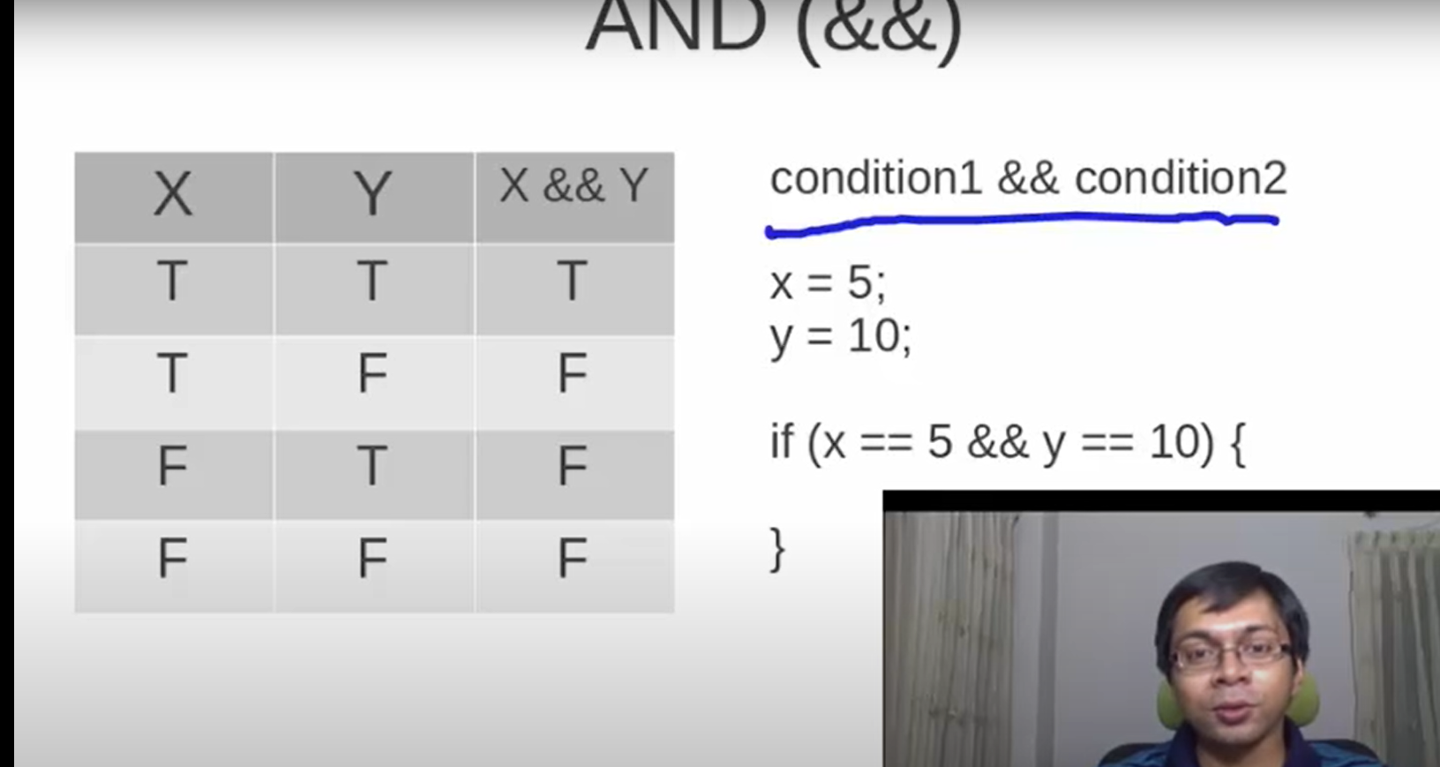

**2.4 Checking digit or not:**

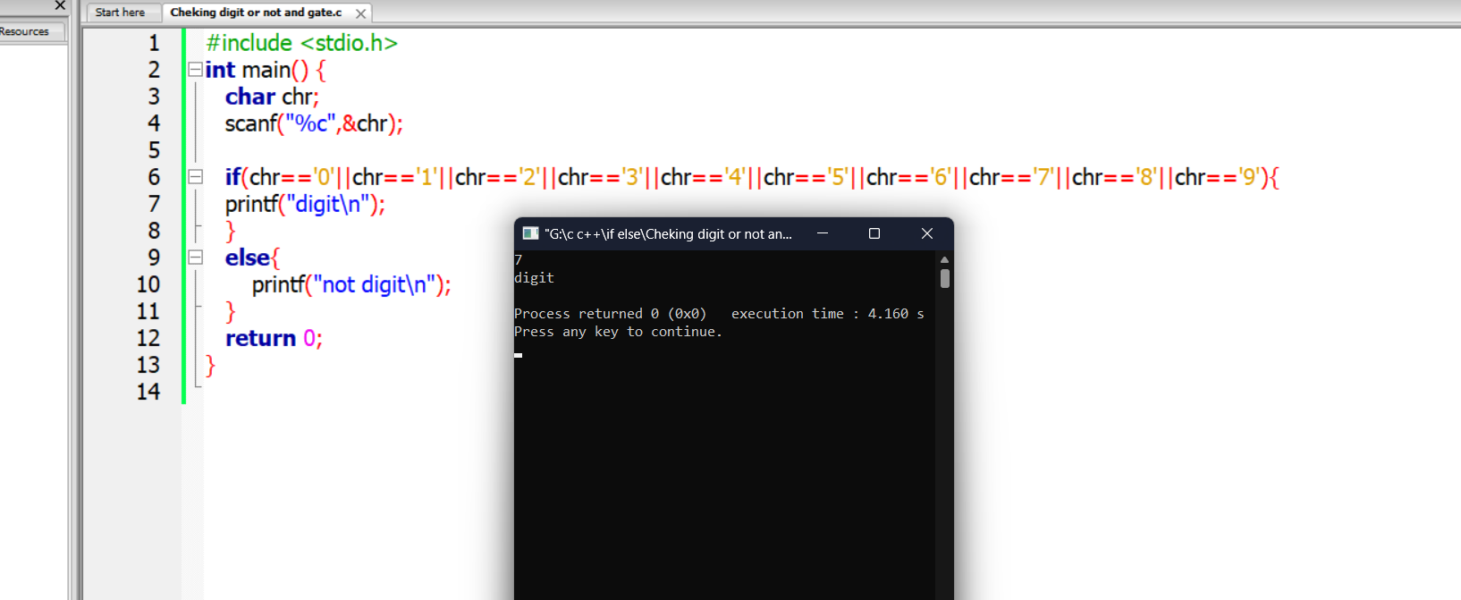

**//short form by and gate:**

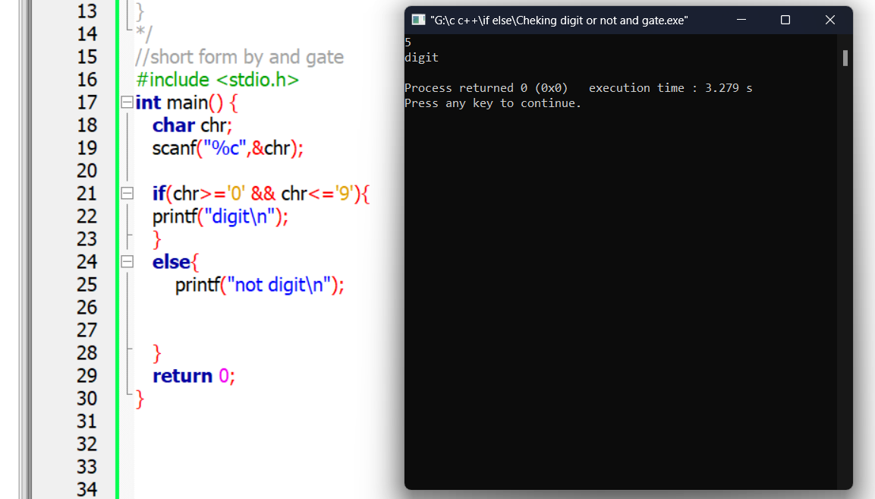

**2.5 Use of else if in grading system:**

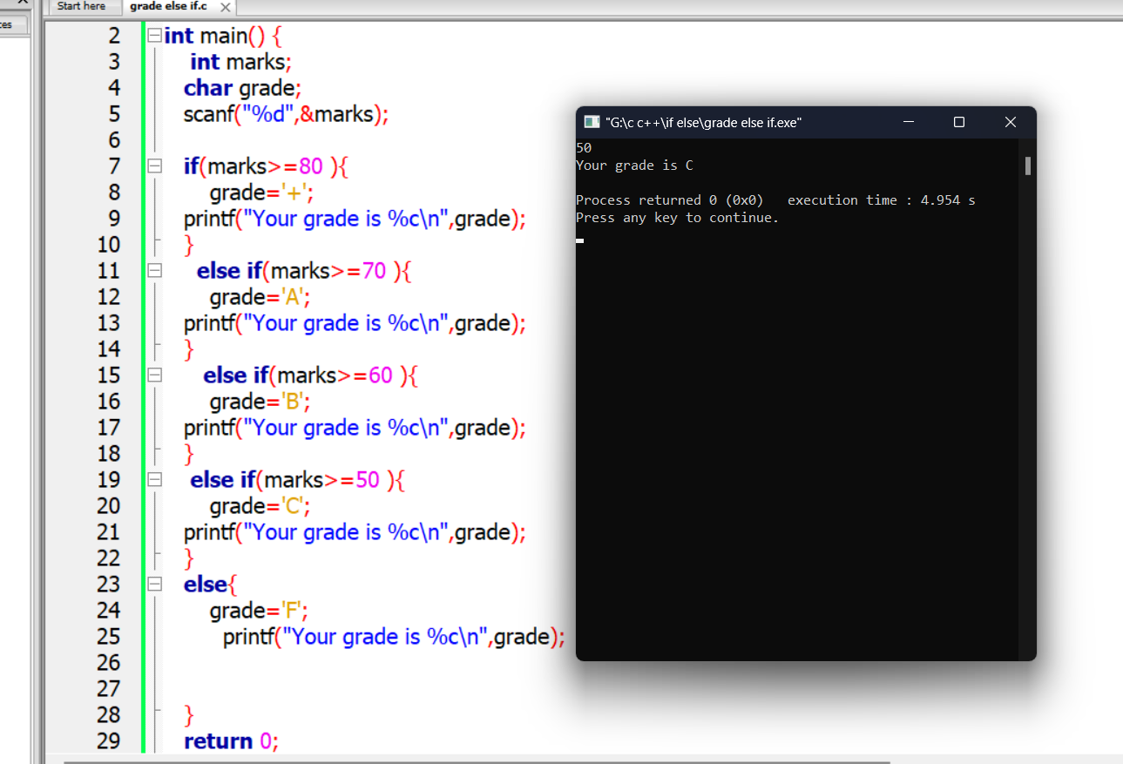

**3.1 Loop introduction**

**1.While loop (like if )**

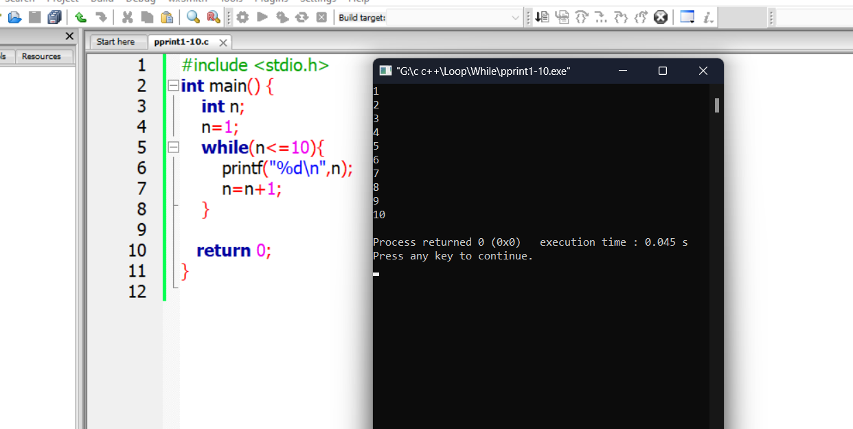

**2.Do while loop**

**3.For loop**

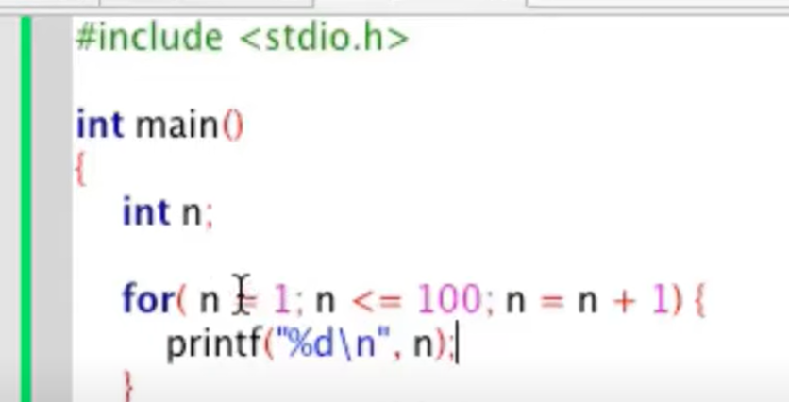

**3.2 While loop:**

**Print 1-10**



**\*\*Print even number use of while and if condition :**

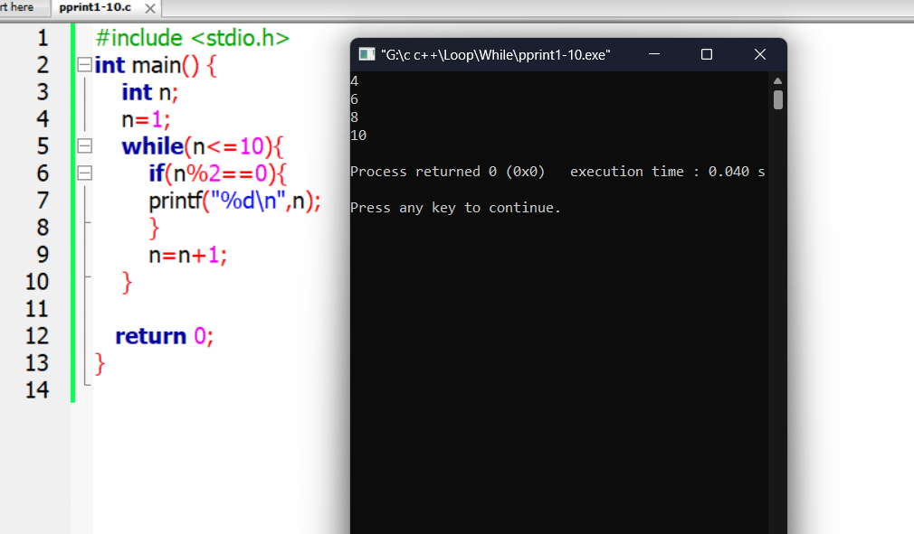

**3.3 for loop: even number with if condition**

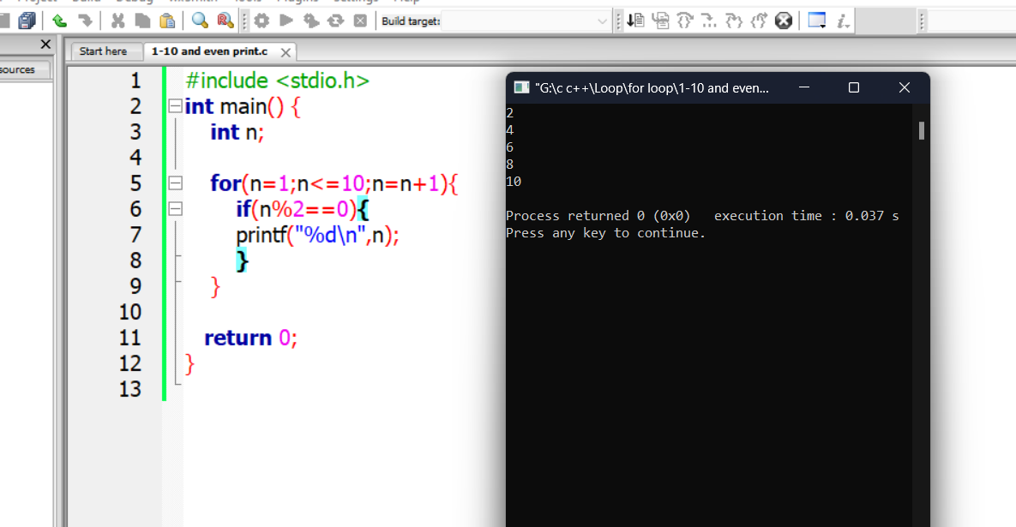

**1-100 print**

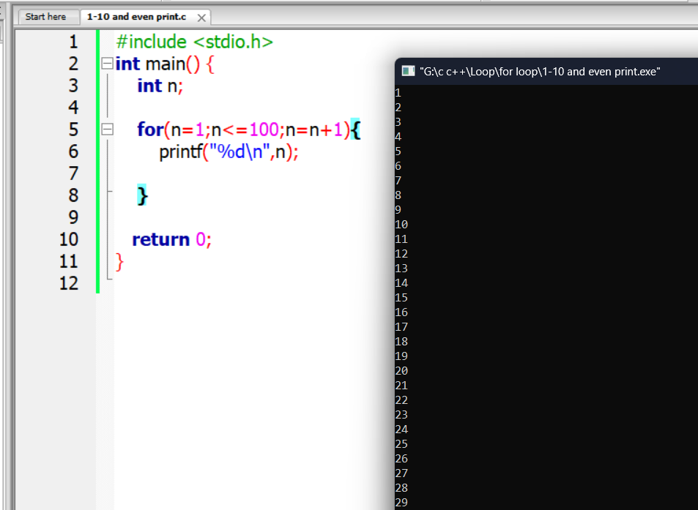

**3.4 break and continue**

**Break:emergency exit from loop**

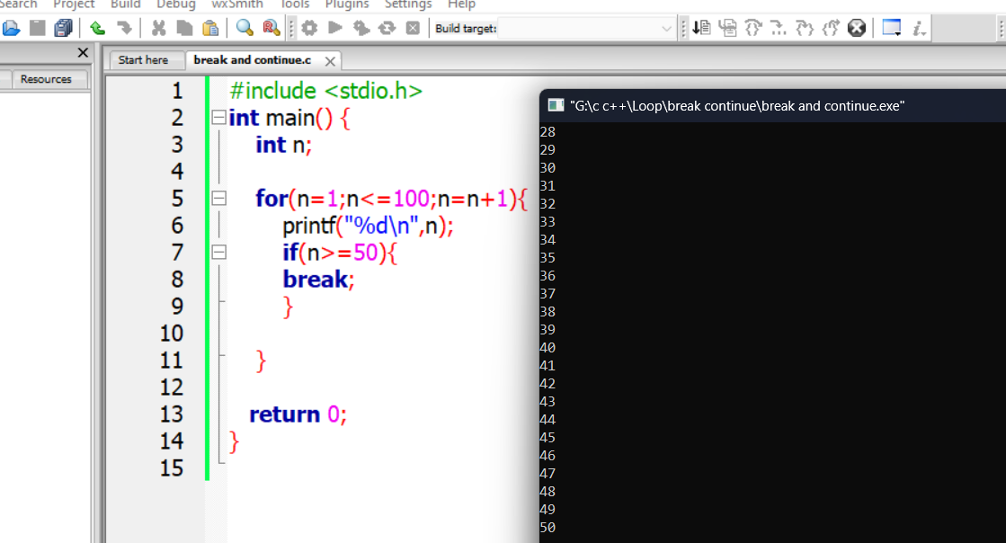

**Continue: After or same value of continue command no looping condition will be executed**

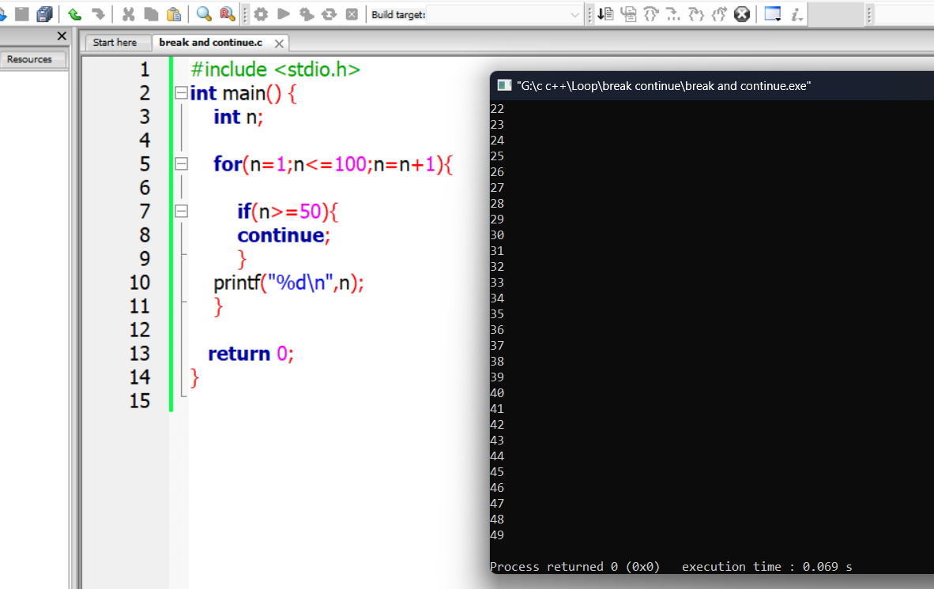

**\*\*Nested for loop:it can be for while nested or while for nested or while while nested loop**

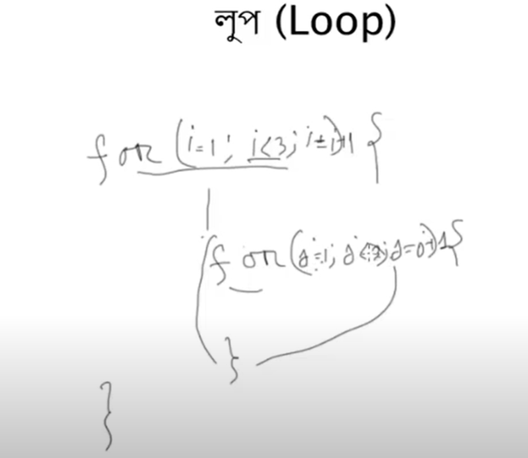

**3.5 For nested loop:**

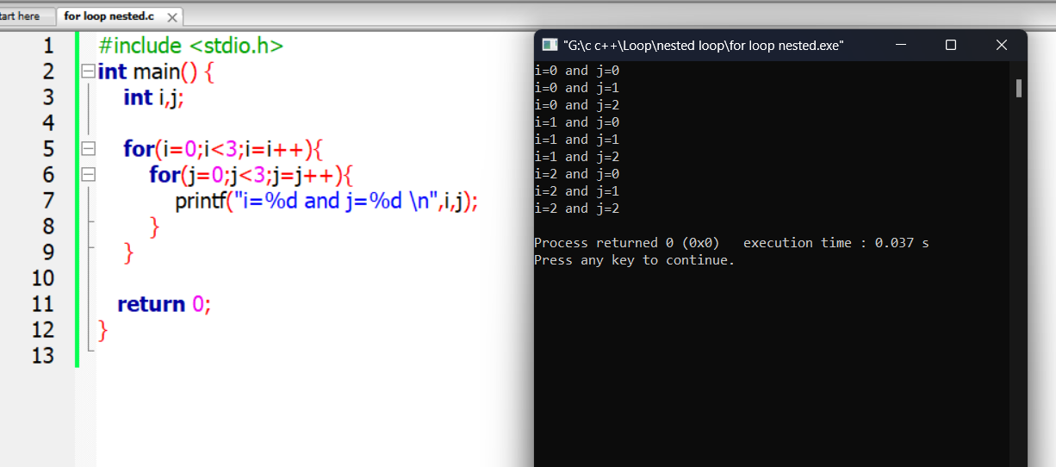

Break inner loop:

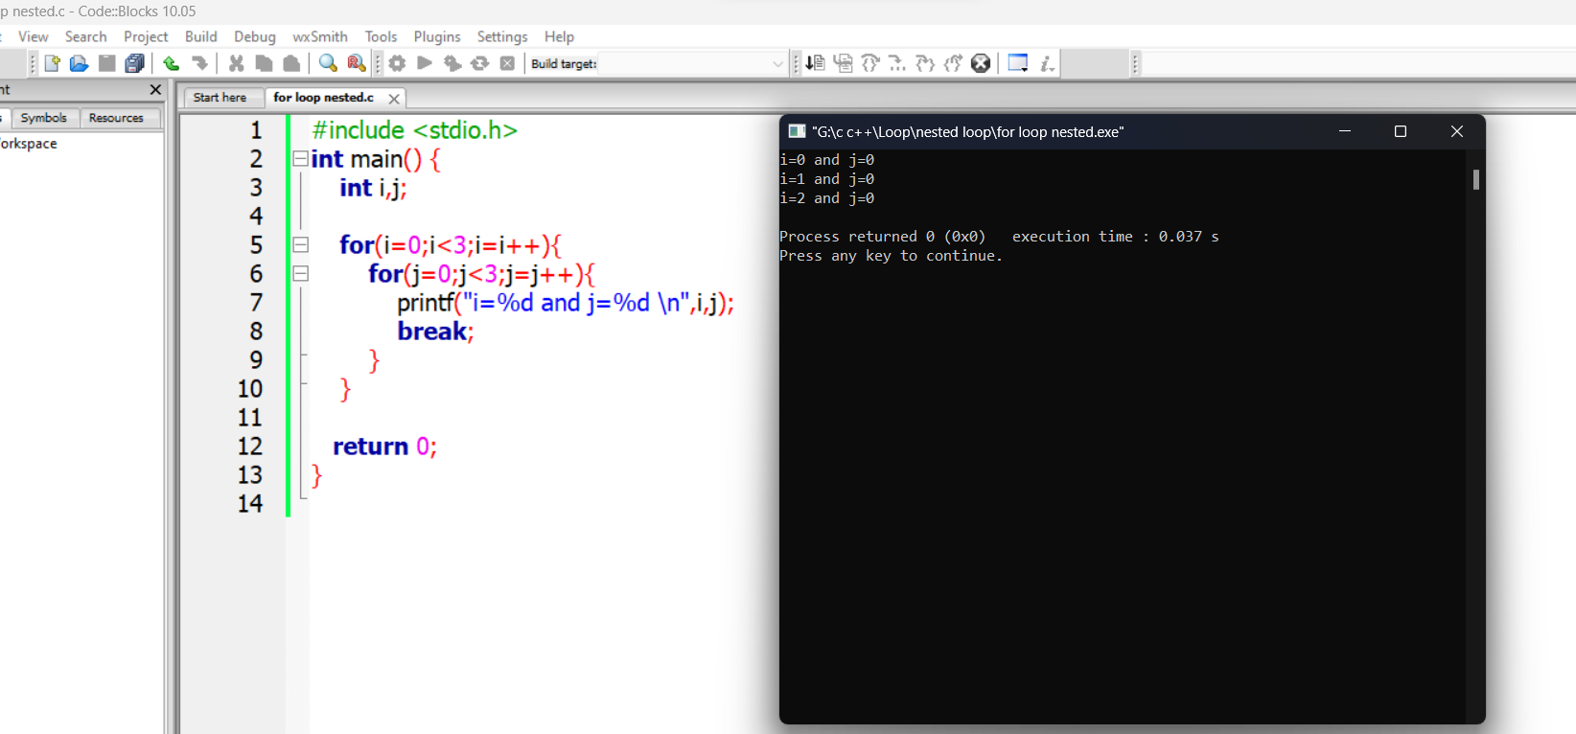

**Break in outer loop:**

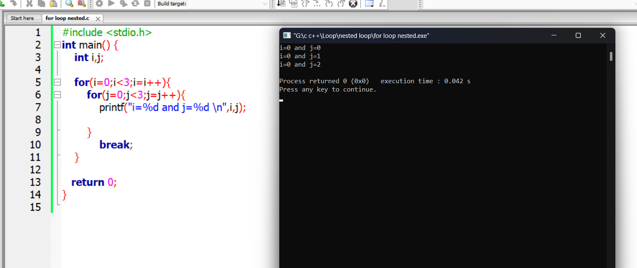

**3.6 Sum Dhara:**

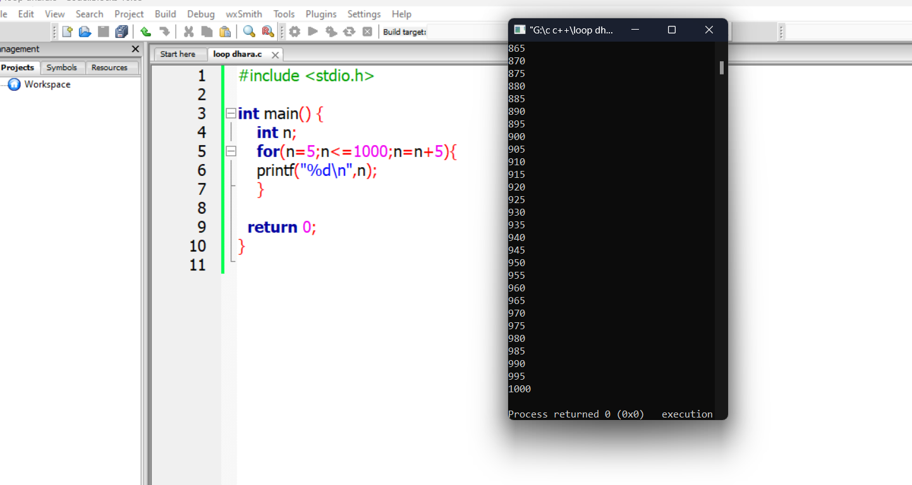

**Dharar jogfol:**

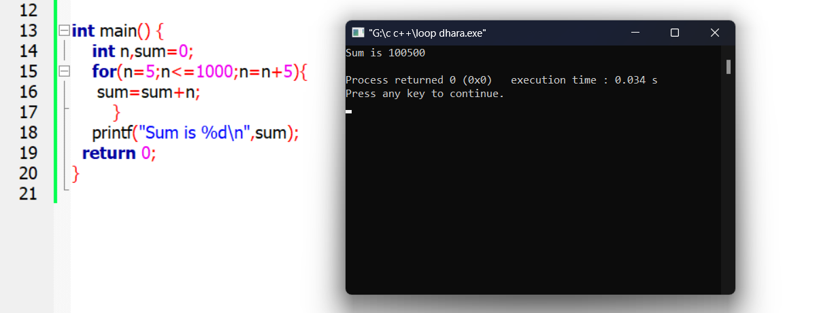

**Dharar jogfol from user value:**

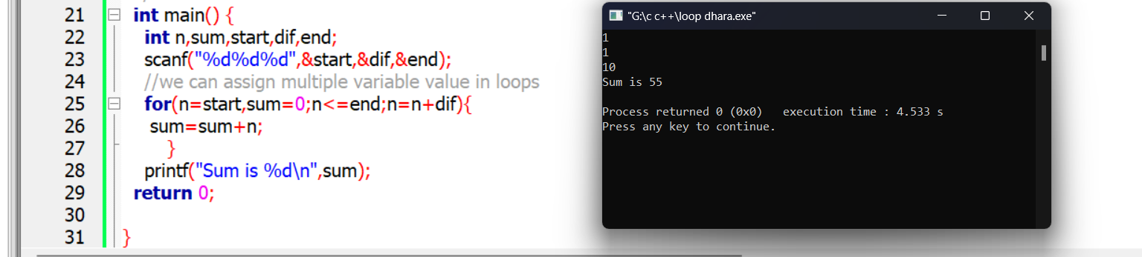

**3.7 Loop Star pattern**

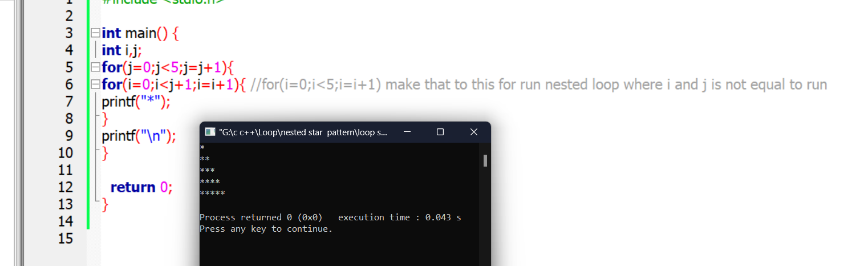

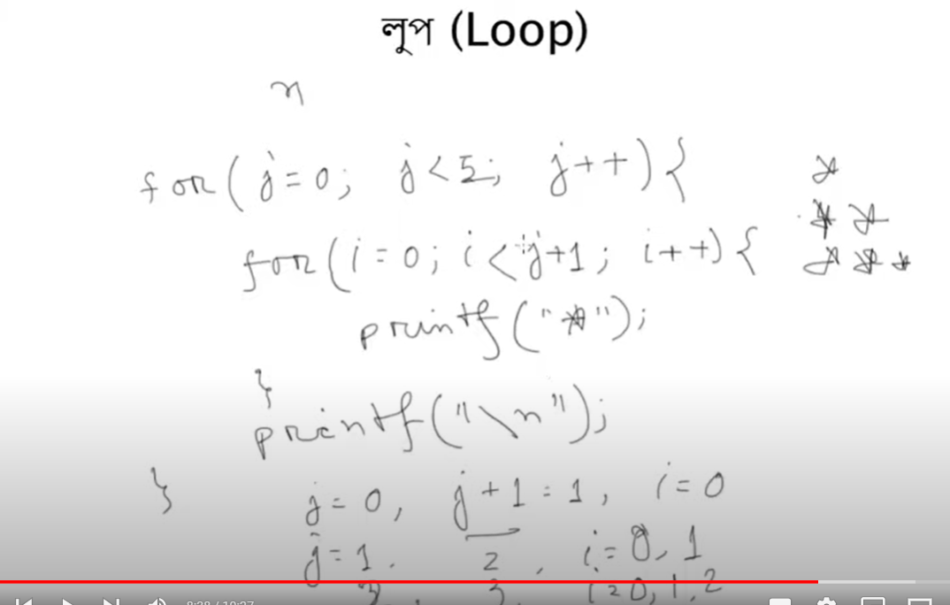

**4.1 What is Function?**

If I need to use same operation multiple times we need to use block instead of code again and again…it is called function .

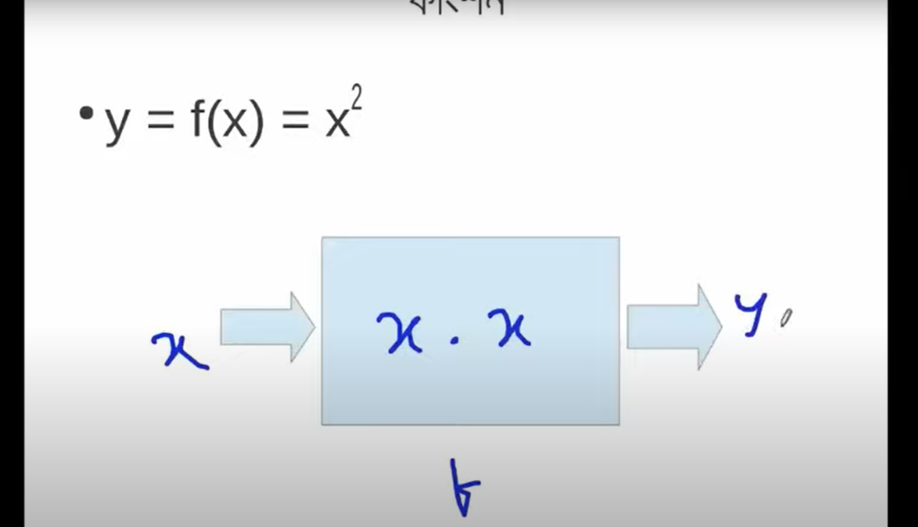

**4.2 prototype of function for this example:**

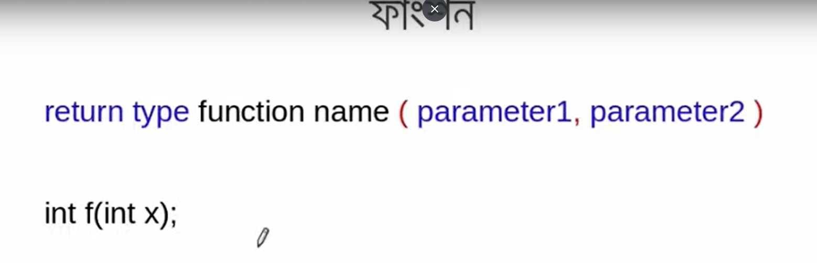

**prototype of function for popcornmaker example:**

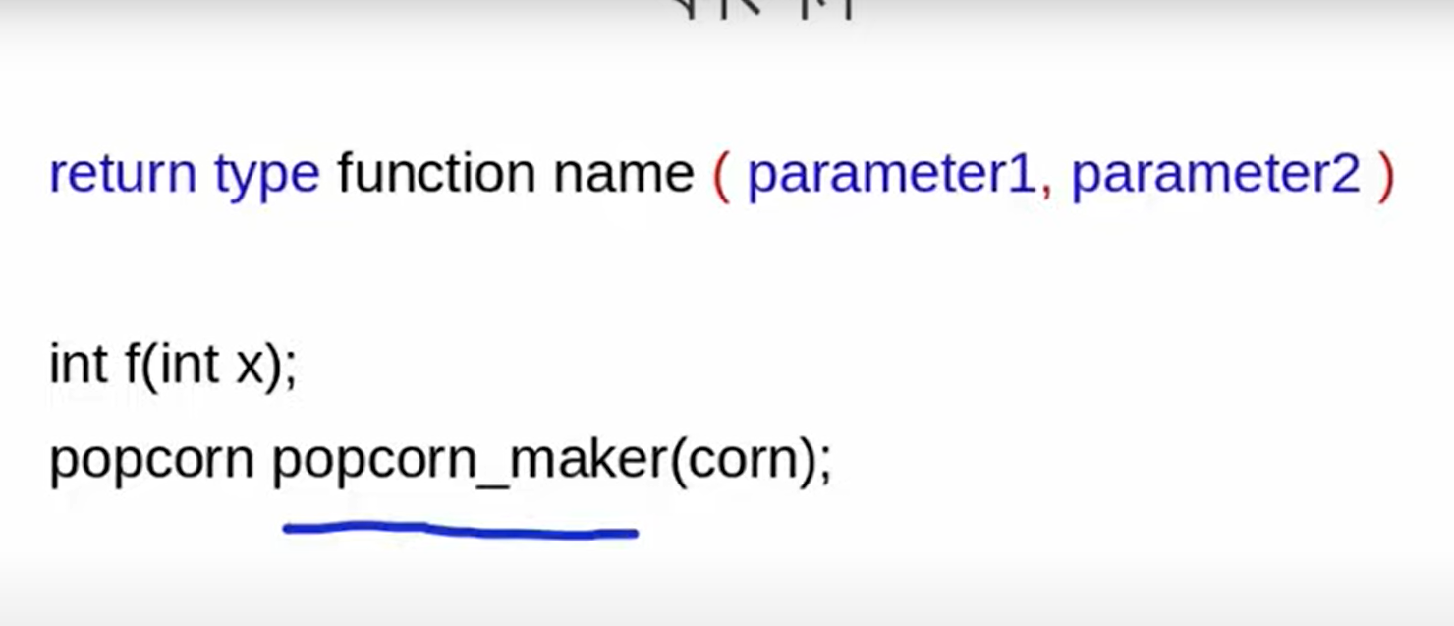

* **(here corn is input ,x is input,dirty cloth,water,detergent is input)**
* **Clean cloth,popcorn is output/return type**
* **Popcorn_maker ,washing machine,f function name**

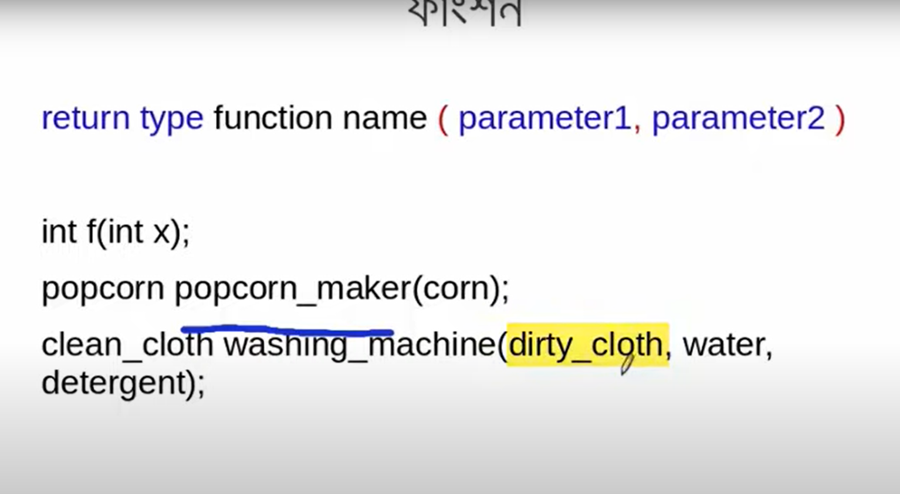

**\*\*\*Library Function:here if we see typecasting exist and square root and power function exist for math header file.\*\***

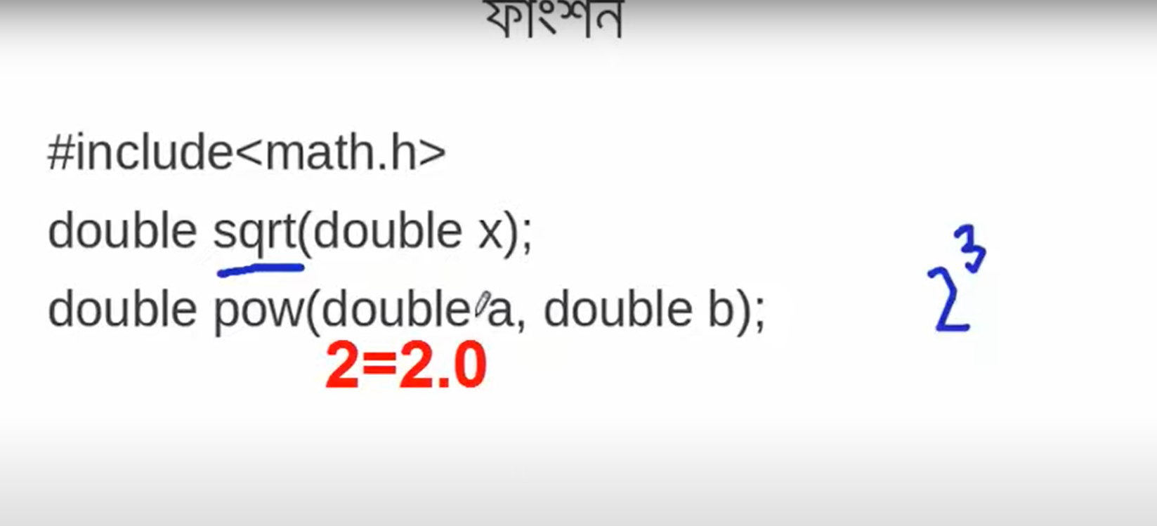

**4.3 Normal problem solving without creating function :**

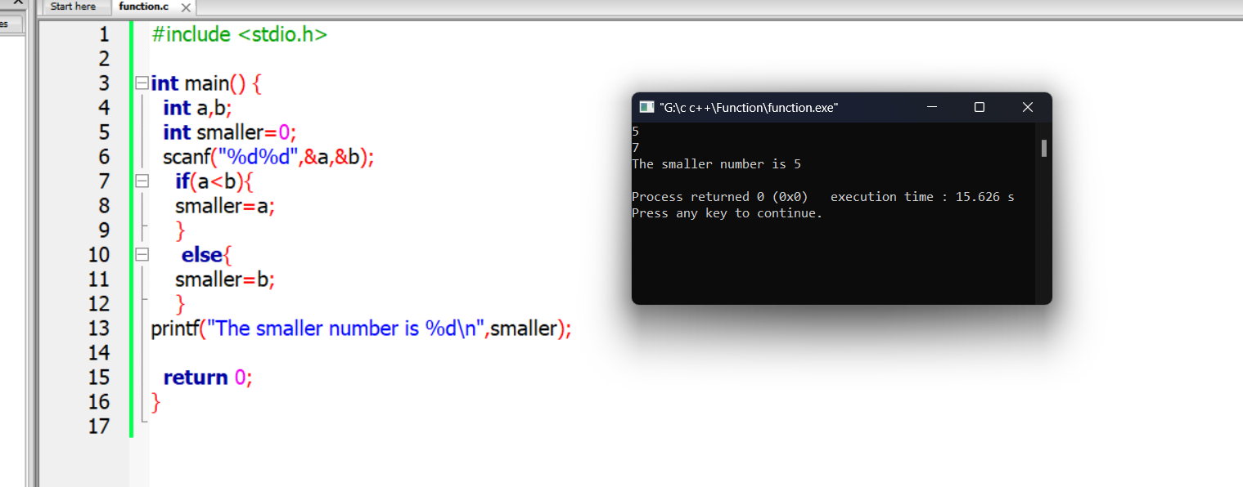

**Normal problem solving with creating function:**

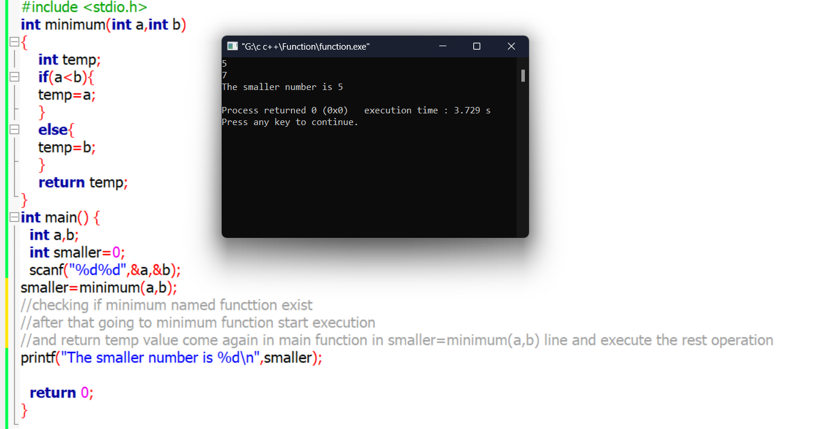

//checking if minimum named functtion exist

//after that going to minimum function start execution

//and return temp value come again in main function in smaller=minimum(a,b) line and execute the rest operation

**4.4 Some examples of Function**

**1.Square of a variable**

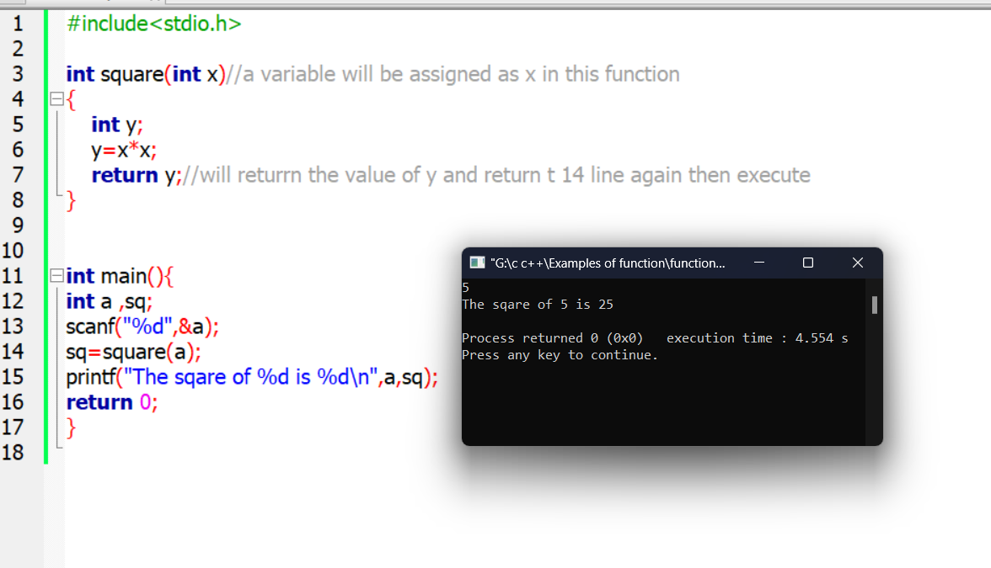

**2.Minimum value among 3 value**

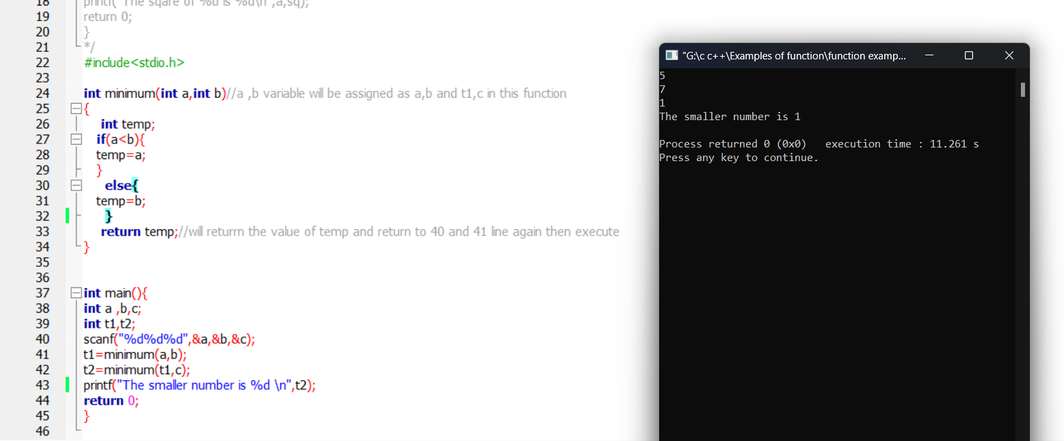

4.5 Array:

In C, an array is like a row of labeled boxes where you can put similar things. Each box has a number, and you use the number to pick the thing inside. The first box is number 0, the

**Array basic Example:**

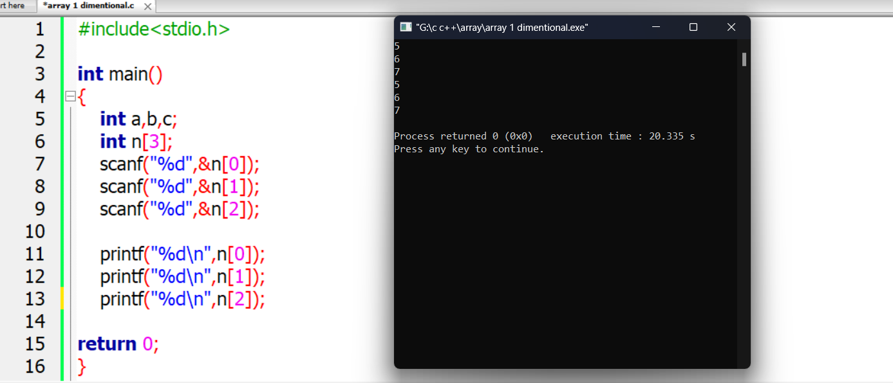

**Actual use of Array: using for loop**

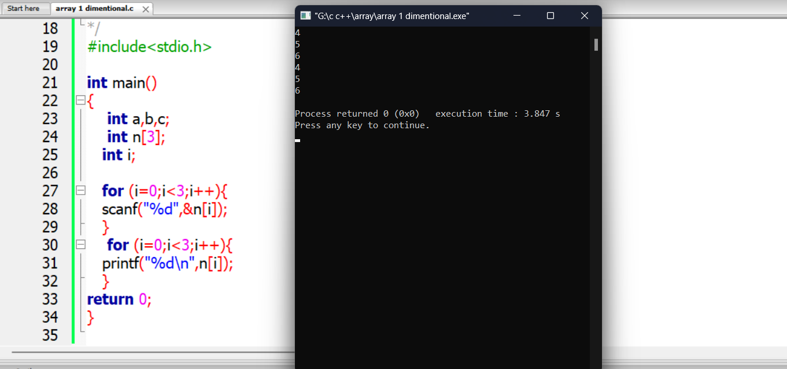

**4.6 one dimentional array**

**Printing Descending order**

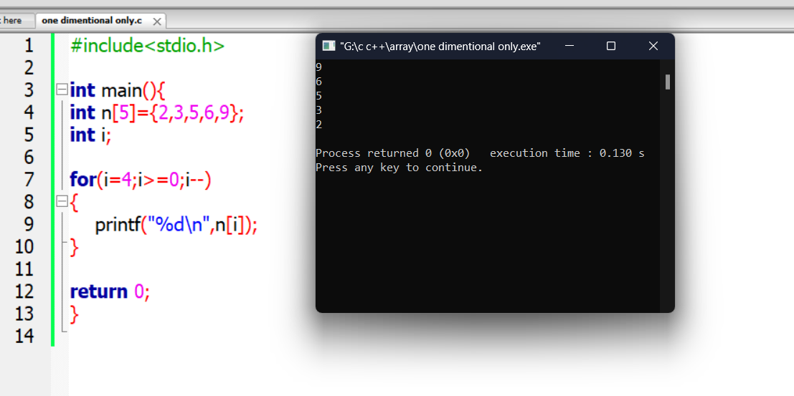

**Printing 3 number index**

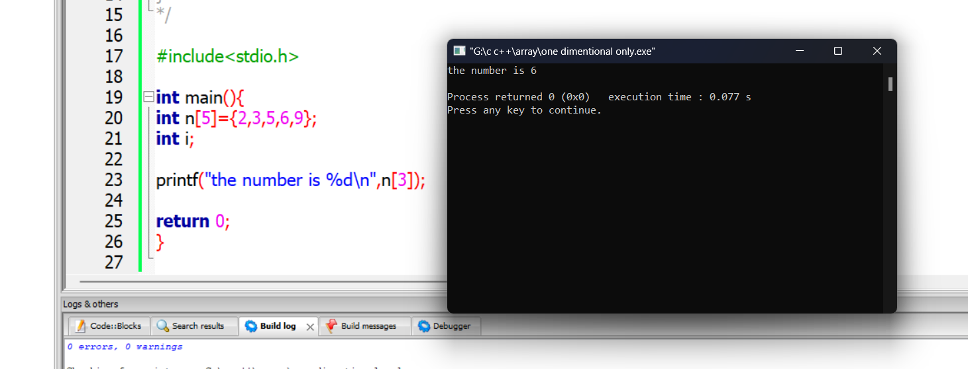

**Marks roll printing**

Roll starts with 1 where array index 0 so we have to minus 1

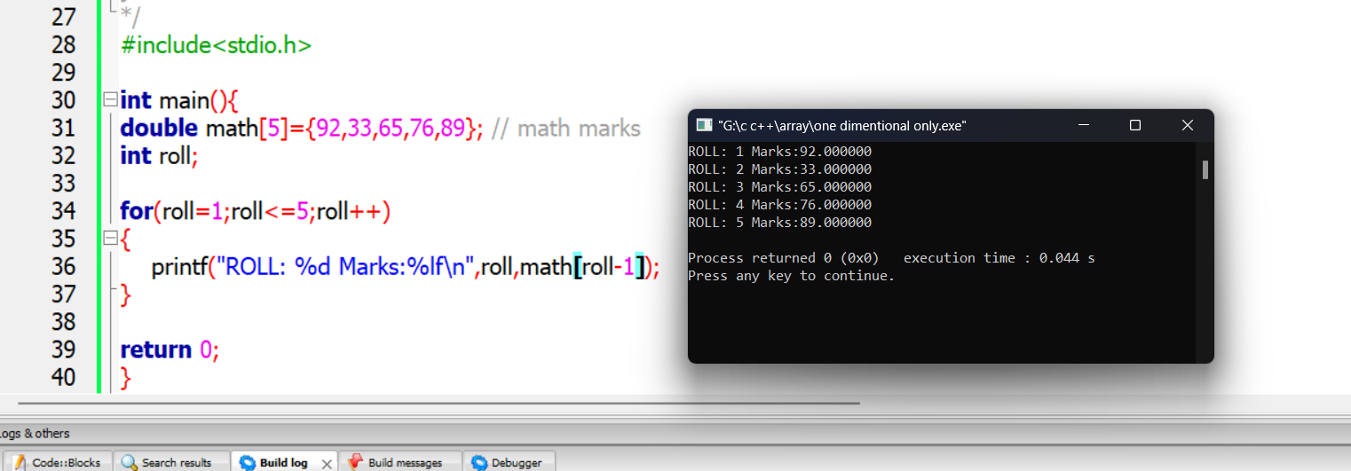

**4.7 2D array:**

A 2D array is also known as a matrix (a table of rows and columns). To create a 2D array of integers, take a look at the following example: int matrix[2][3] = { {1, 4, 2}, {3, 6, 8} }; The first dimension represents the number of rows [2], while the second dimension represents the number of columns [3].another easy example of 2d array structurte

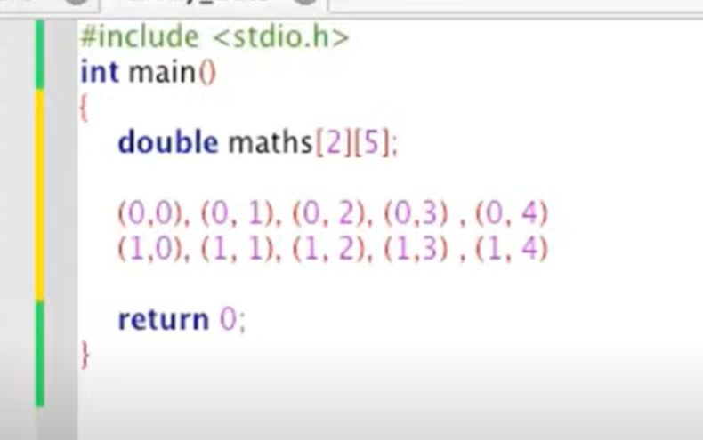

Prolems like amar karo marks jante roll and class 2 tai lagbe er jonno 2 D array

**Printing a 2d index data:**

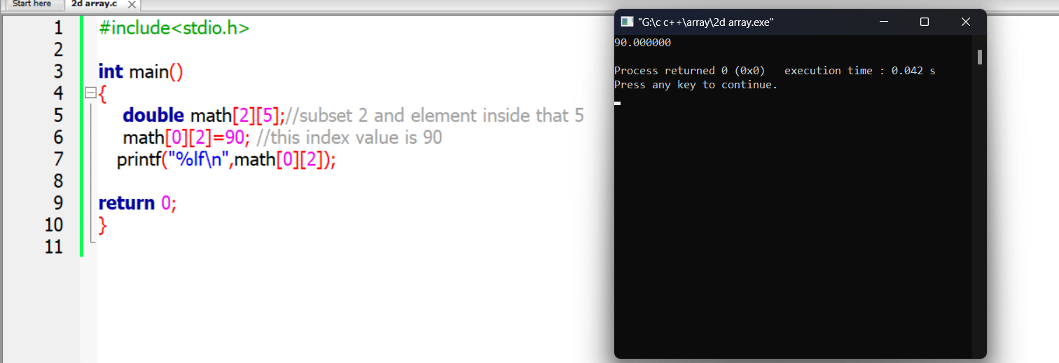

**Class roll marks 2d array solve:**

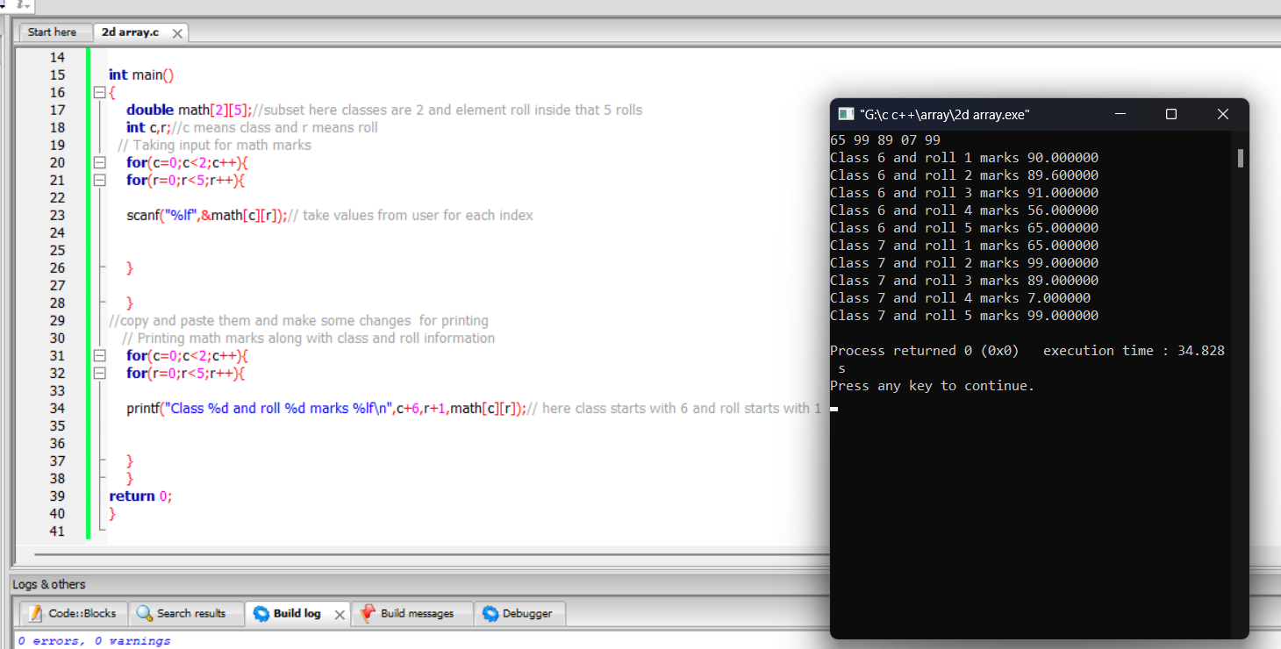

**4.8 2D array more detailed examples:**

**Table system 10*10 limit:**

**This code has limitations like not exceeding 10 numbers**

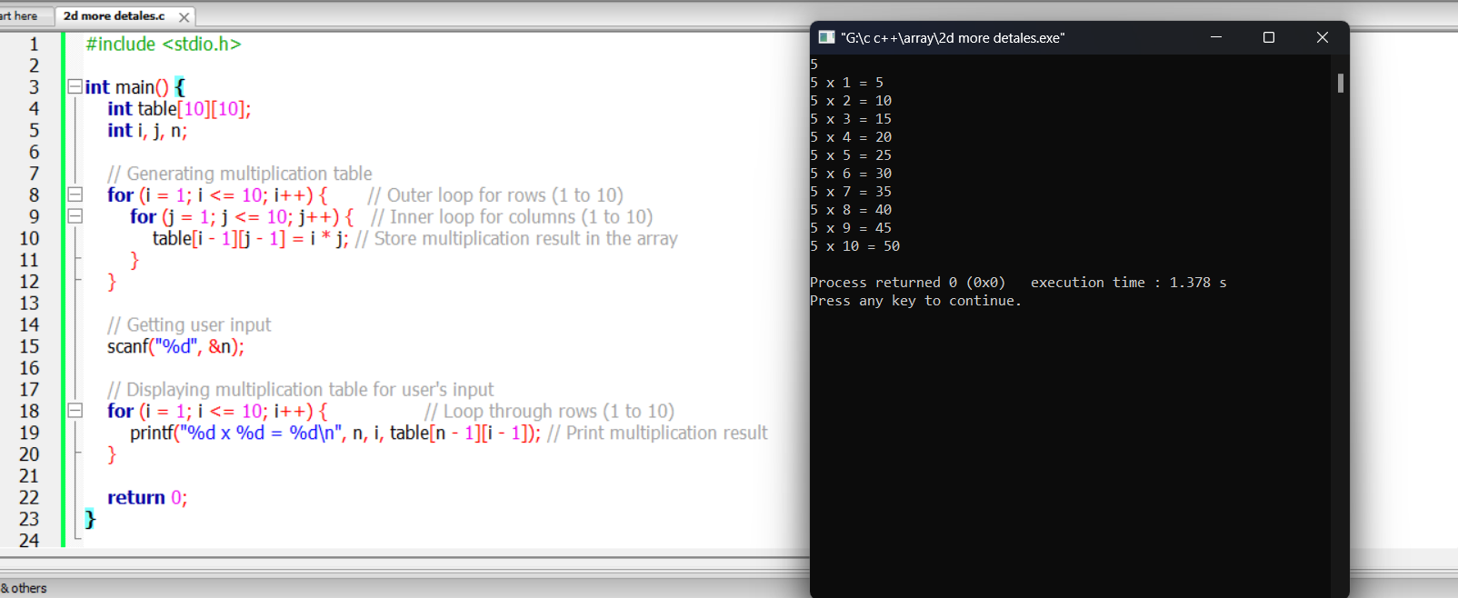

**2D array index printing example:**

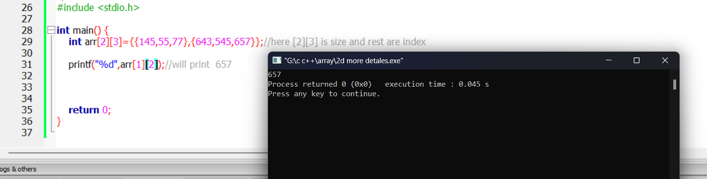

**5.1 String intro:**

(Character er array) Character type array

1.X and Y er value assigned jekono block theke start korte pare

But starting theke sequentially thakbe jmn Bangladesh

2.Int hole 2-4 byte and char hole 1 byte dokhol korbe

3.Str nijei memory address nirdesh kore tai & not needed

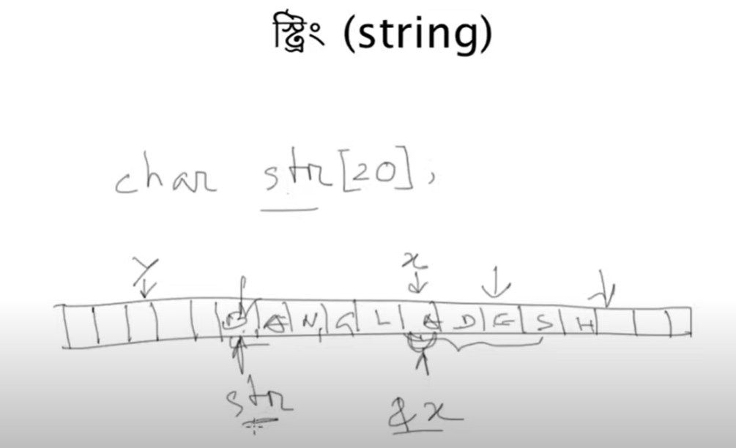

**Printing a string :**

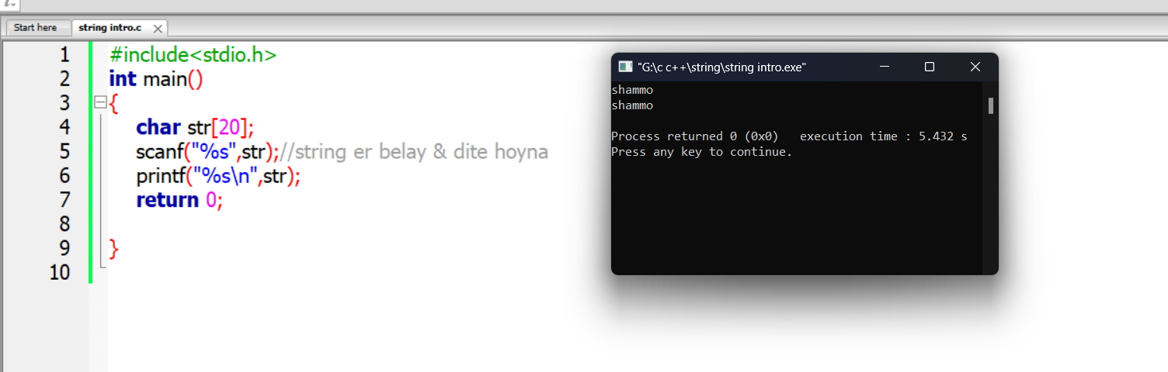

**5.2 String Initialization**

**1.to print null character in sizeless str put**

**‘\n’ (IT will print Bangla)**

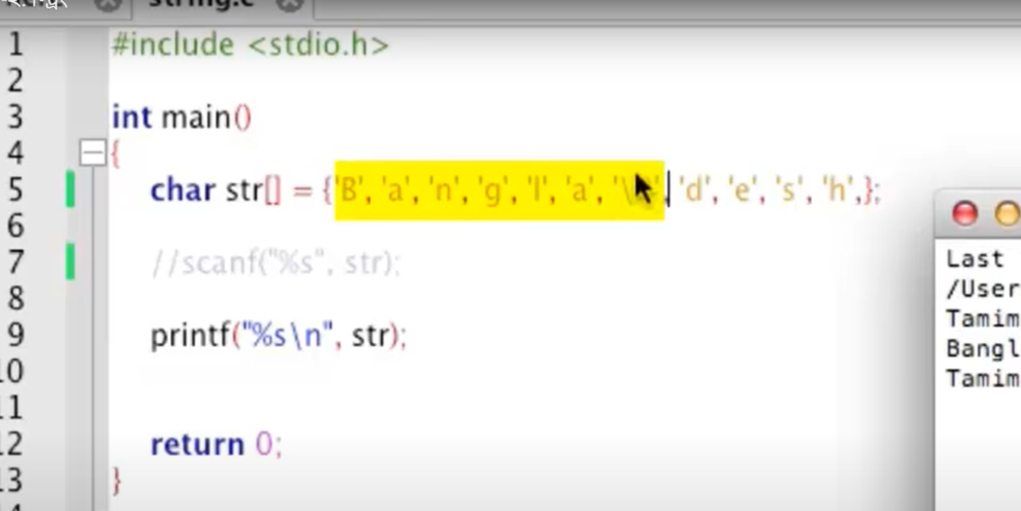

Normal Initialization: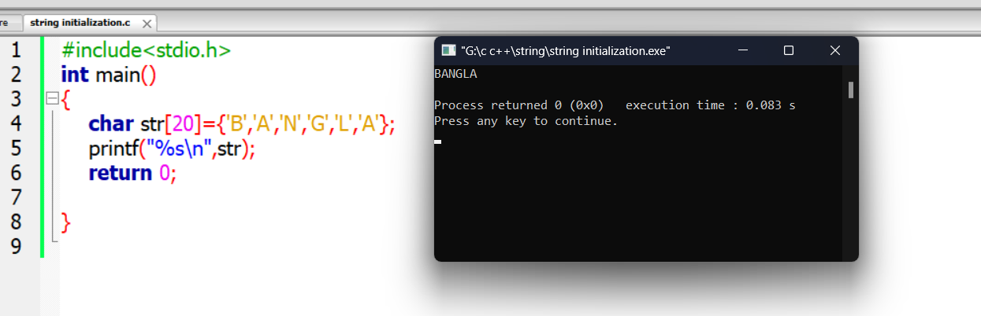

Short tech:here the problem is 20 size,19actual value with space

and 1 null value for ending

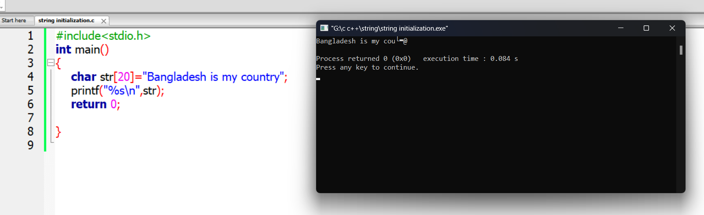

**Solved By increasing size:**

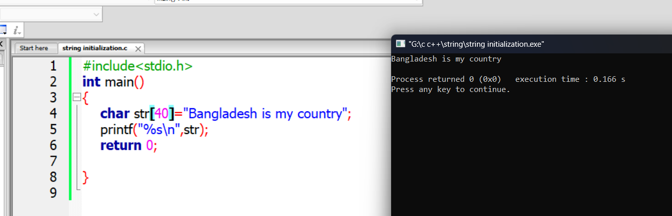

Scanning string with space :

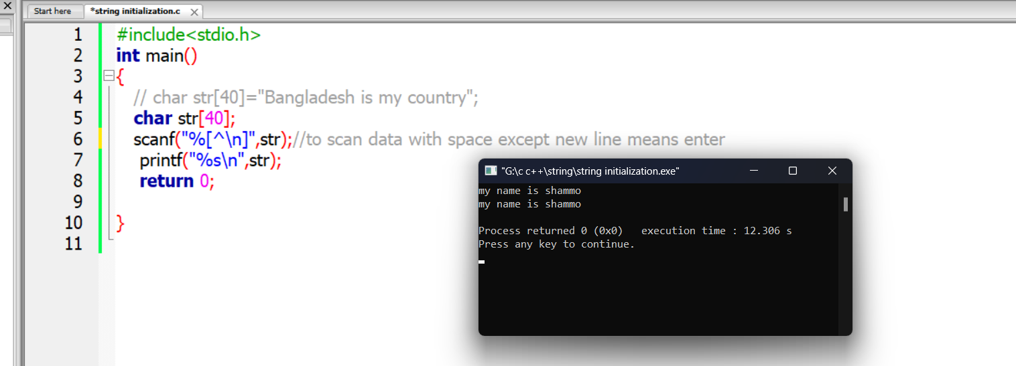

5.3 String length counting

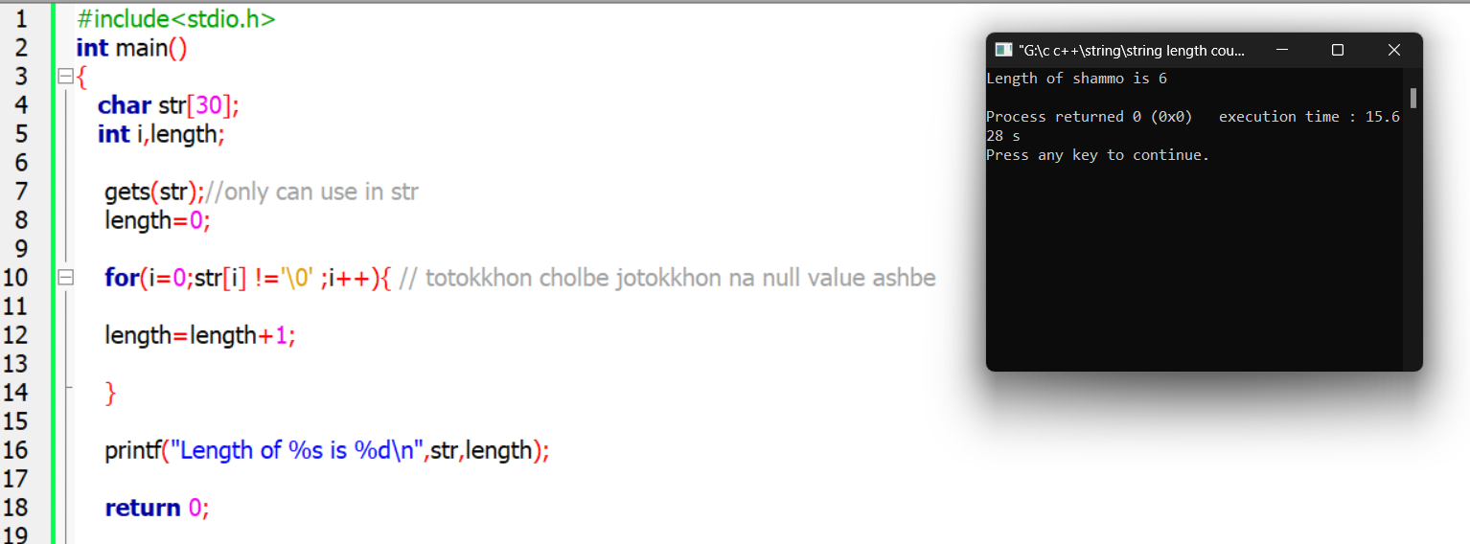

5.4 Reversing string

%c reads a single character from the input stream and stores it to a single char object. %s reads a sequence of character values from the input stream until it sees whitespace

Simple solution but has some bugs

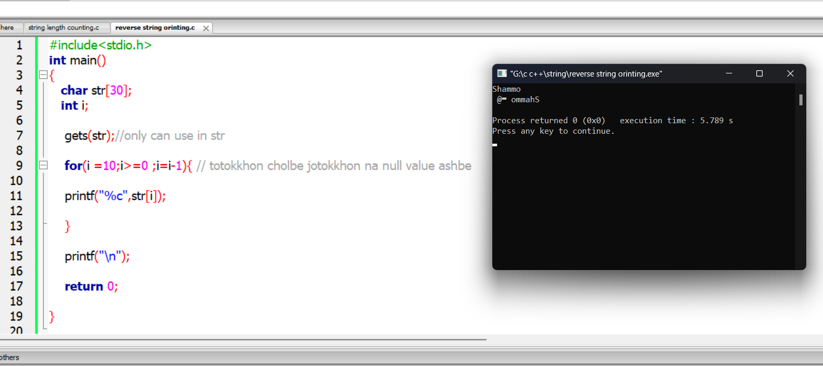

More accurate: but if we increase the range like 5 to 10 same problem occurs

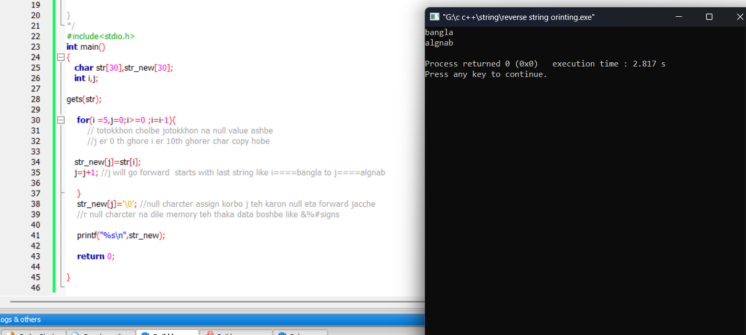

**5.5 String connection:**

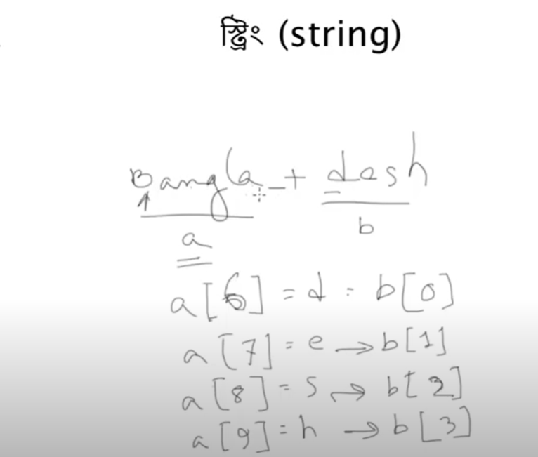

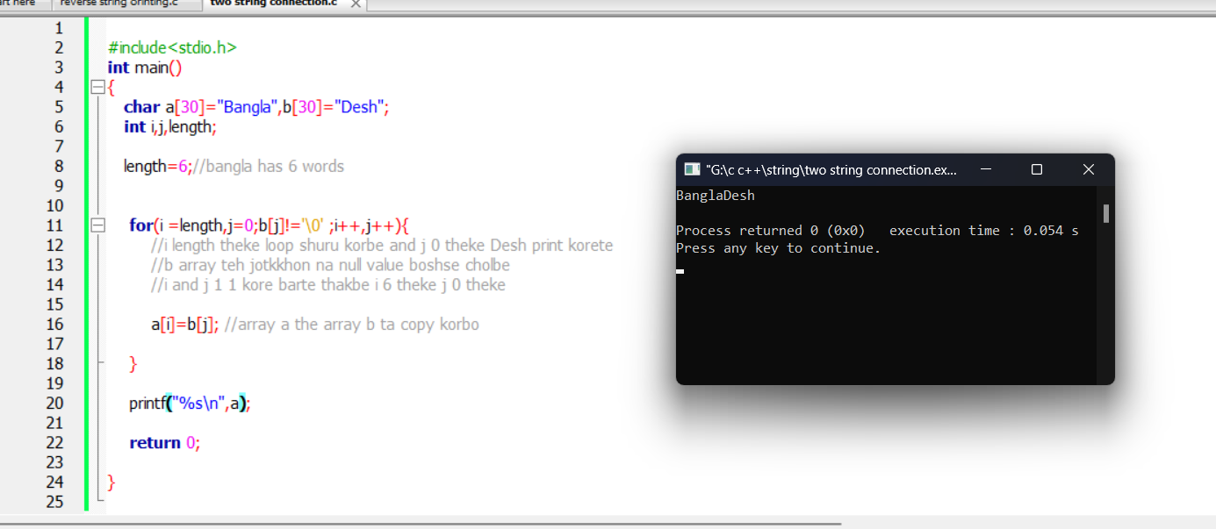

5.6 ASCII

**Printing char and its ASCII value**

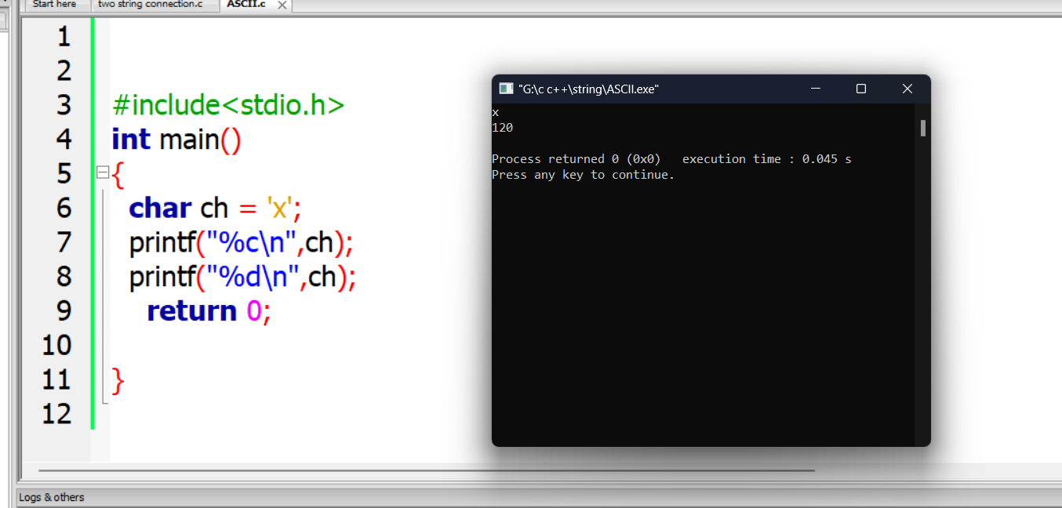

Printing Ascii all values of char:

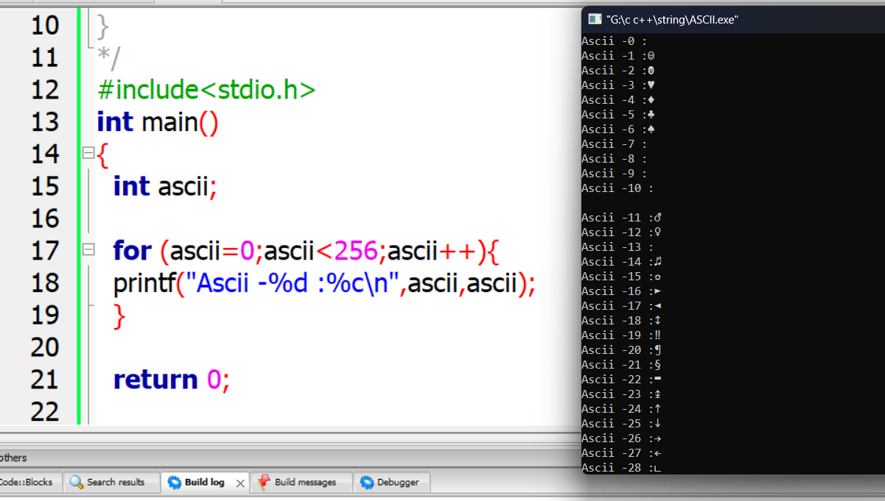

Capitalise:

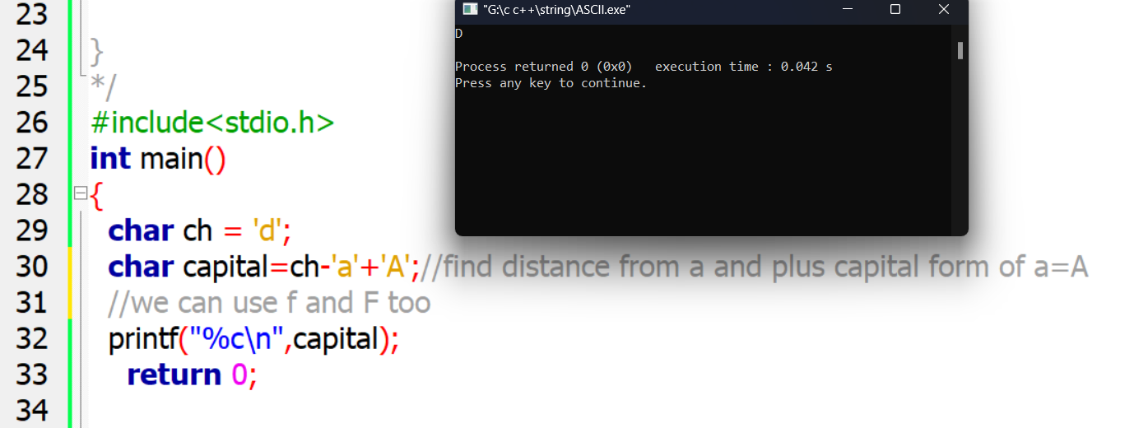

To print A just -3:

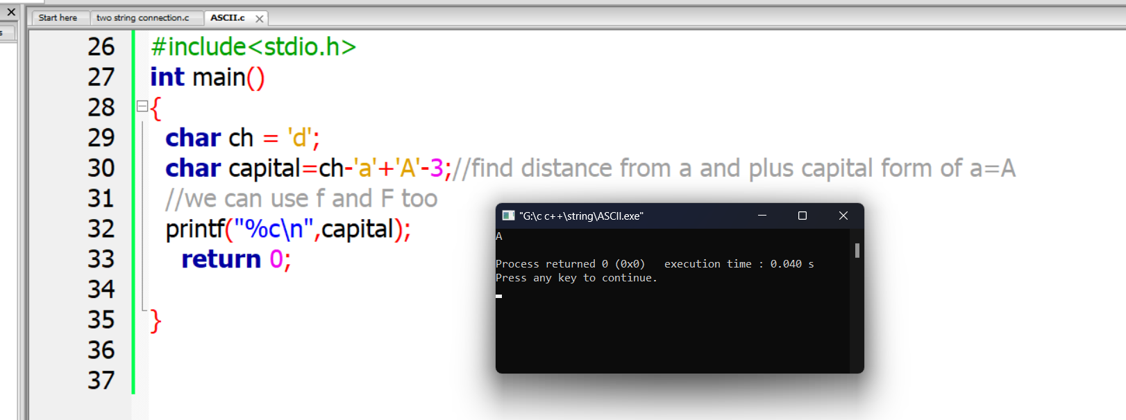

**5.7:String Array means Character array er array**

**Like 2D Array holo Array er Array**

**3 name and name length 10**

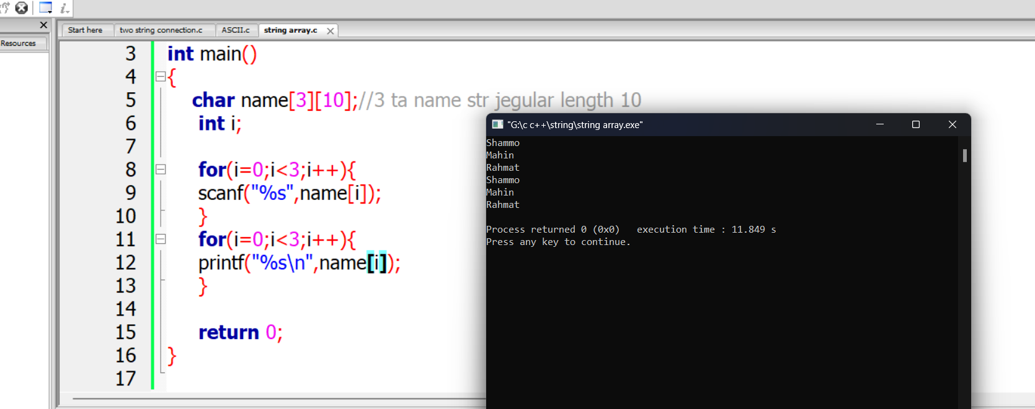

**Another way1:**

**Another way1:**

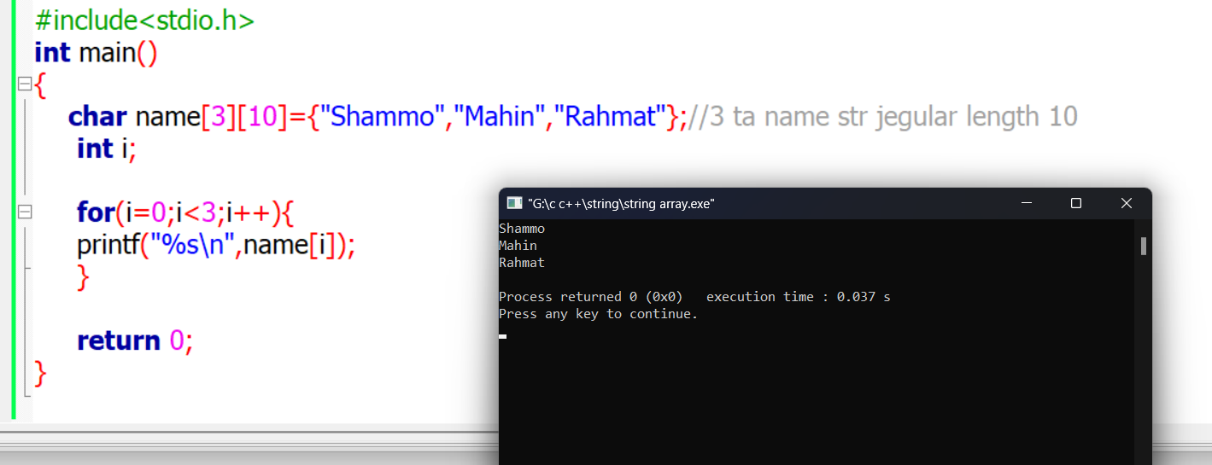

**Another way2:here string use “” and char used ‘ ‘**

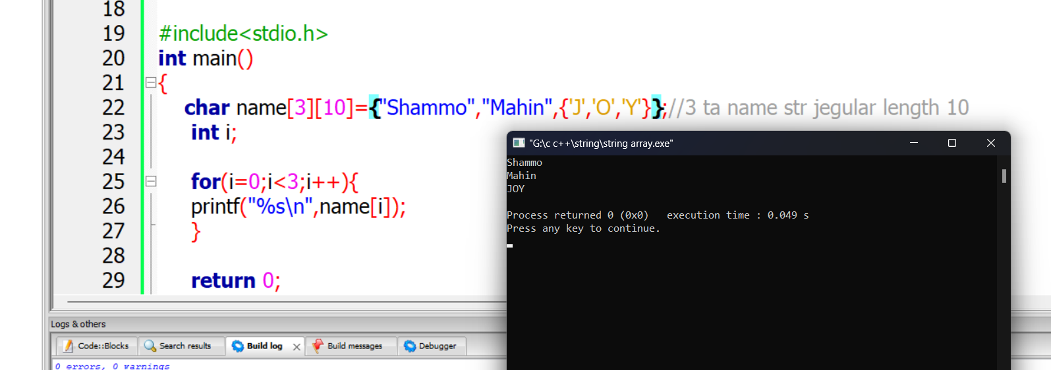

6.1 File input/output

Input from file and then show it in the screen:

**Input means output from file:**

Fgets()

//r for read mode w for write mode,have many modes like this

// for storing into a string

//fgets is a function liek gets for file

//(string name,strng size,file name)

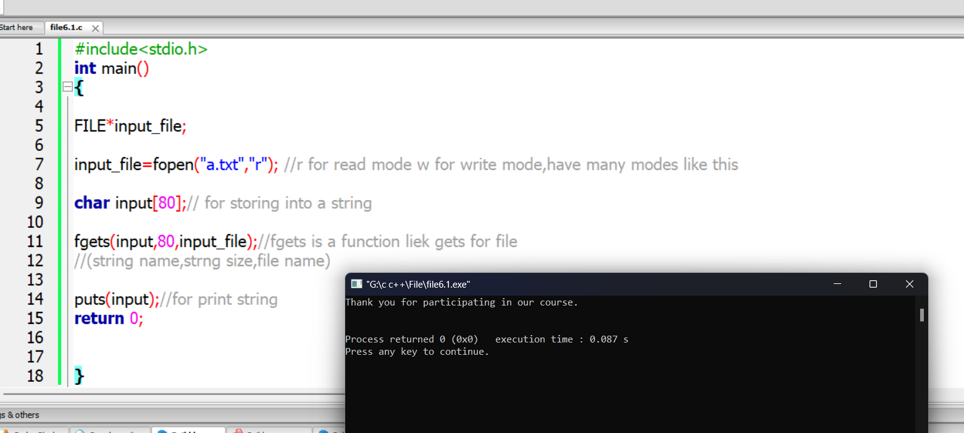

**Output means input to file:**

**Fputs()**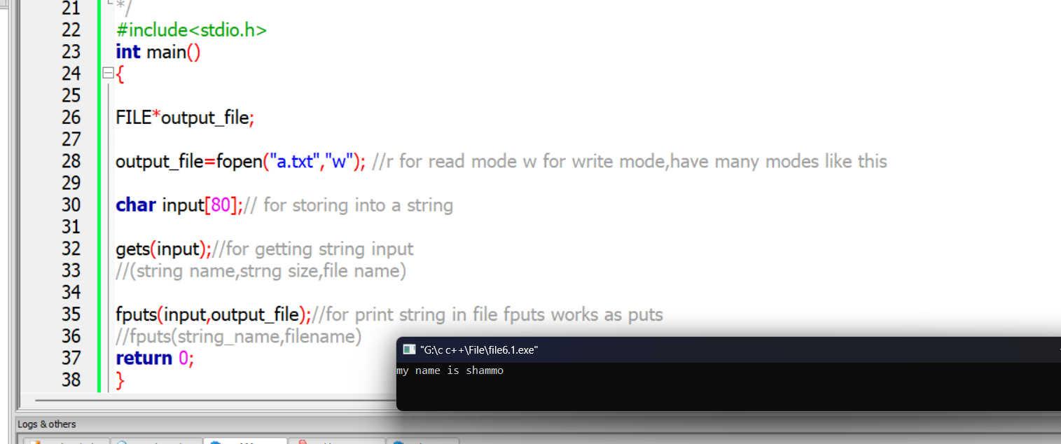

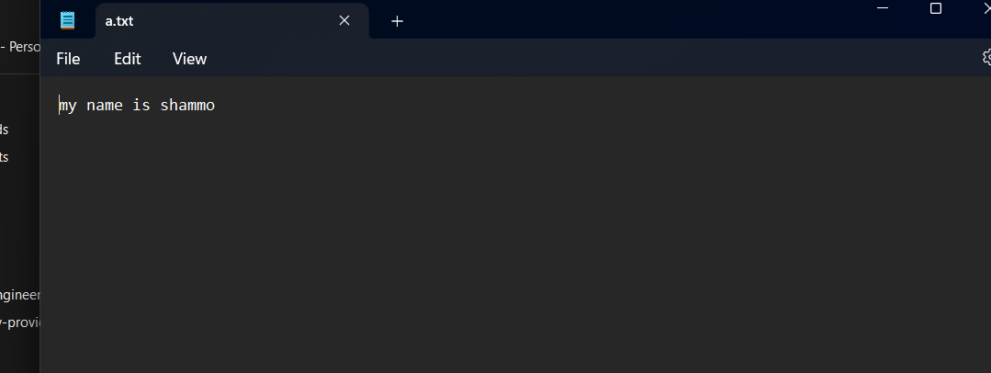

File’s inside data have been changed**

**6.1.2 Use of fscanf and fprintf: input_output both using file**

**Step1: FILE*input_file,*output_file;**

**2:fopen**

**3:variable declaration and operation**

**4.fscanf**

**5.fprintf**

**6.fclose()**

Using file input for fetch values and then output to write down in output file.

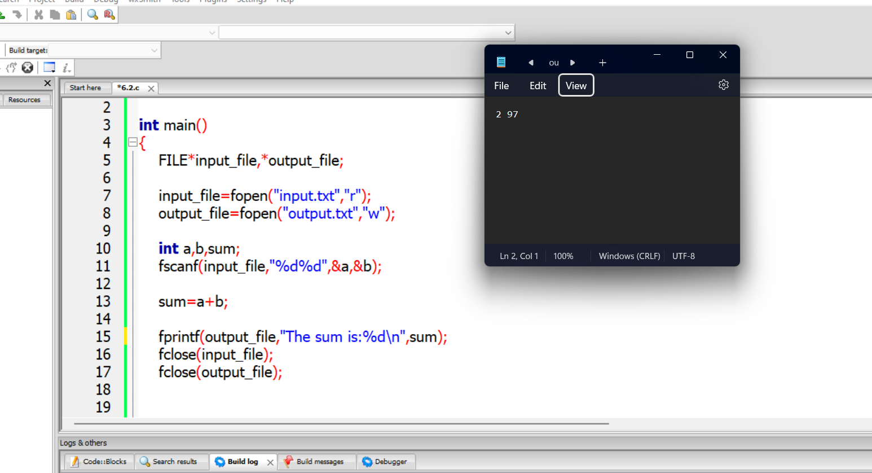

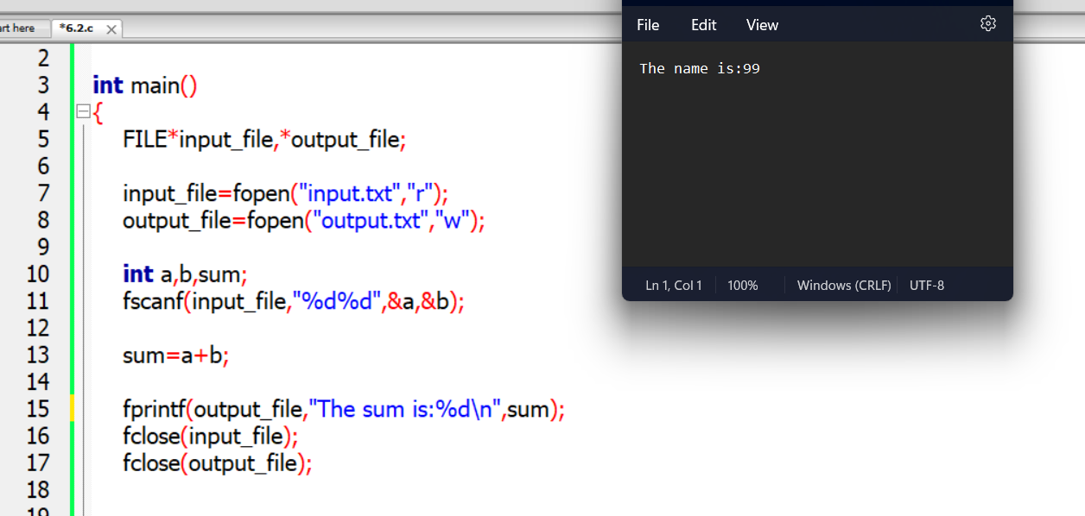

6.2 Structure: Collection of variable

**/*char name [10] [10];//phone book e 10 joner data thakbe and 10 size er naam**

**char phoneno [10] [15];//phone no 10 joner 15 size**

**char email [10] [15];**

**//here is the main problem is we can not understand is there any interconnection among them thats why we use structure**

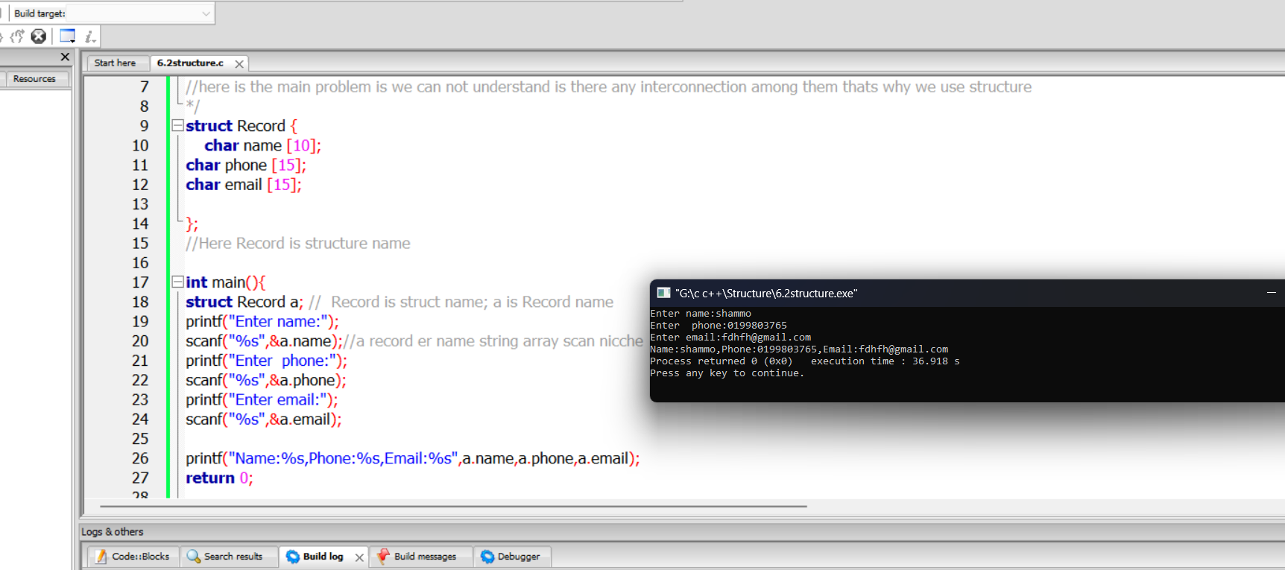

**Ex2: Assign to a then transfer to b ;b=a**

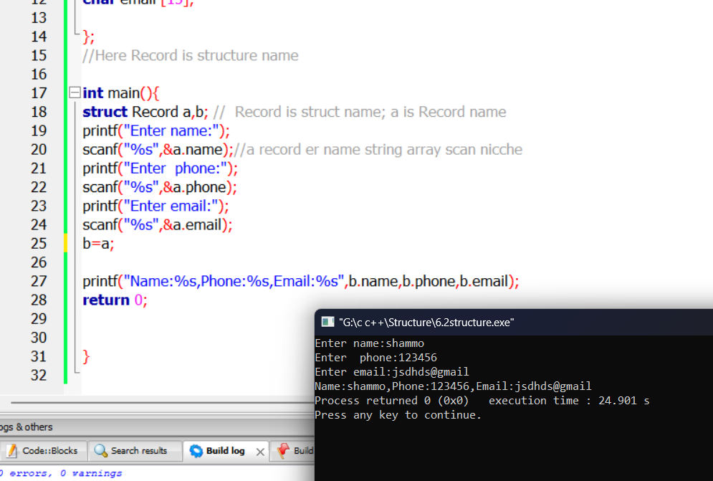

6.3 Structure Array

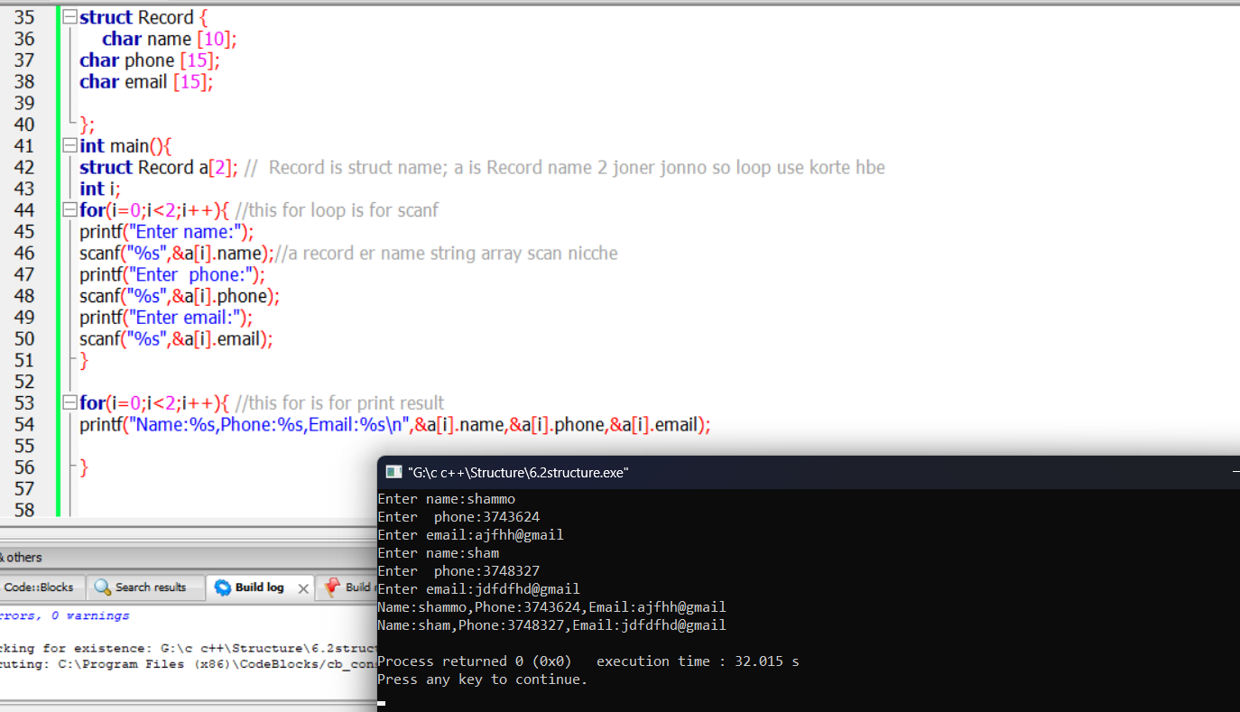**Record is struct name; a is Record name 2 joner jonno so loop use korte hbe**

6.4 **File Shortcut : without FILE pointer or fopen**

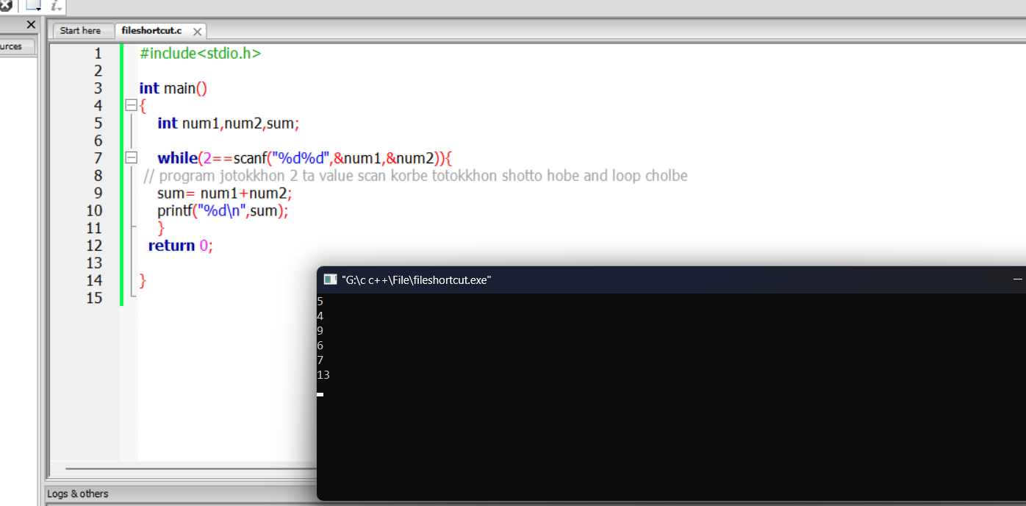

**From filereopen input and output:**

**We need to write extra 2 line above the prev code**

**Input:**

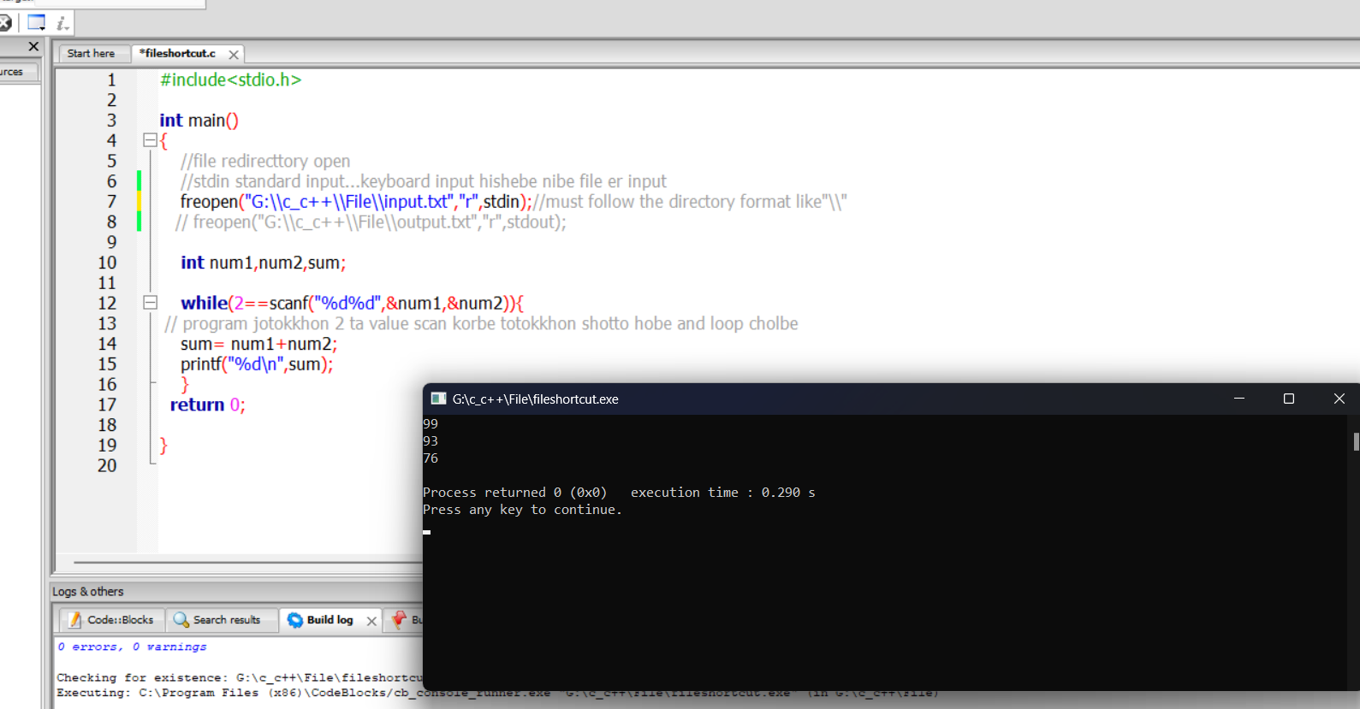

**Output:**

